Lift Catalogue
No.1 | YSJ-3000 Two Post Lift, 3Tons  With symmetrical Lifting arms, 3.0 tons  FOB Dalian Container Price: USD800  FOB Dalian Sample Price: USD880  Specifications:  1. Lifting capacity: 3000Kg  2. Post Height: 2880mm  3. Car max lifting height: 1800mm  4. Lift min stand height: 120mm  5. Clearance between posts: 2794mm  6. Total width: 3420mm  7. Lifting Time: 40s (Adjustable)  8. Lowering Time: 30s (Adjustable)  9. Voltage: 110V/220V/380V/415V, 1ph/3ph  10. Noise: <70dB  11. Net Weight: 700Kg  Gross Weight: 750Kg  12. Packing Dimension:  2900mm*560mm*720mm  770mm*280mm*340mm  13. Cubic Meter: 1.24cbm  14. Shipping: 24 pieces / 20’ container | 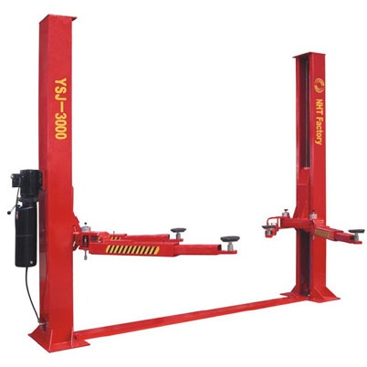
No.2 | YSJ-3000B Two Post Lift, 3Tons  With symmetrical Lifting arms, 3.0 tons  FOB Dalian Container Price: USD880  FOB Dalian Sample Price: USD968  Specifications:  1. Lifting capacity: 3000Kg  2. Post Height: 2880mm  3. Car max lifting height: 1800mm  4. Lift min stand height: 120mm  5. Clearance between posts: 2794mm  6. Total width: 3420mm  7. Lifting Time: 40s (Adjustable)  8. Lowering Time: 30s (Adjustable)  9. Voltage: 110V/220V/380V/415V, 1ph/3ph  10. Noise: <70dB  11. Net Weight: 700Kg  Gross Weight: 750Kg  12. Packing Dimension:  2900mm*560mm*720mm  770mm*280mm*340mm  13. Cubic Meter: 1.24cbm  14. Shipping: 24 pieces / 20’ container | 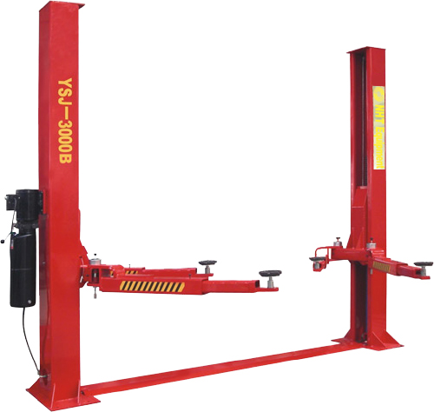
No.3 | YSJ-3000C Two Post Lift, 4Tons  With symmetrical Lifting arms, 4.0 tons  FOB Dalian Container Price: USD960  FOB Dalian Sample Price: USD1056  Specifications:  1. Lifting capacity: 4000Kg  2. Post Height: 2880mm  3. Car max lifting height: 1800mm  4. Lift min stand height: 120mm  5. Clearance between posts: 2794mm  6. Total width: 3420mm  7. Lifting Time: 40s (Adjustable)  8. Lowering Time: 30s (Adjustable)  9. Voltage: 110V/220V/380V/415V, 1ph/3ph  10. Noise: <70dB  11. Net Weight: 710Kg  Gross Weight: 760Kg  12. Packing Dimension:  2900mm*560mm*720mm  770mm*280mm*340mm  13. Cubic Meter: 1.24cbm  14. Shipping: 24 pieces / 20’ container | 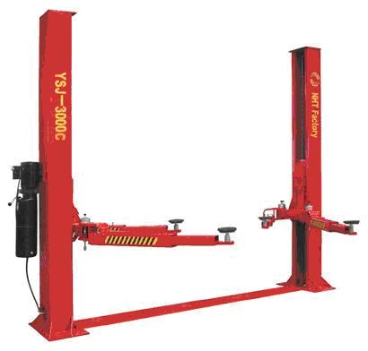
No.4 | YSJ-3000C Two Post Lift Electric Control Version  With symmetrical Lifting arms, 4.0 tons  FOB Dalian Container Price: USD1040  FOB Dalian Sample Price: USD1144  Specifications:  1. Lifting capacity: 4000Kg  2. Post Height: 2880mm  3. Car max lifting height: 1800mm  4. Lift min stand height: 120mm  5. Clearance between posts: 2794mm  6. Total width: 3420mm  7. Lifting Time: 40s (Adjustable)  8. Lowering Time: 30s (Adjustable)  9. Voltage: 110V/220V/380V/415V, 1ph/3ph  10. Noise: <70dB  11. Net Weight: 720Kg  Gross Weight: 770Kg  12. Packing Dimension:  2900mm*560mm*720mm  770mm*280mm*340mm  13. Cubic Meter: 1.24cbm  14. Shipping: 24 pieces / 20’ container | 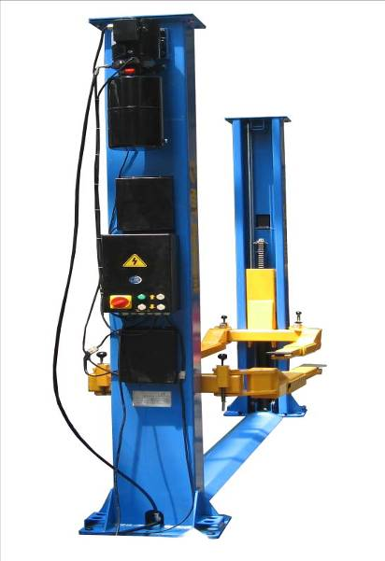
No.5 | YLJ-3600 Two Post Lift, 3.6Tons  With asymmetrical Lifting arms, 3.6 tons  FOB Dalian Container Price: USD1035  FOB Dalian Sample Price: USD1087  Specifications:  1. Lifting Capacity: 3600Kg  2. Max Lift Height: 1850mm  3. Post Height:3912mm  4. Minimum height: 120mm  5. Clearance between carriages: 2750mm  6. Total width:3450mm  7. Lifting Time: 40s (Adjustable)  8. Lowering Time: 30s (Adjustable)  9. Voltage: 110V/220V/380V/415V, 1ph/3ph  10. Motor Power: 2.2Kw  11. Noise: <70dB  12. Net Weight: 830Kg  Gross Weight: 880Kg  13. Cubic Meter: 2.04cbm  14. Shipping: 9 pieces / 20’ container  18 pieces / 40’ container  Left space is suitable for 6pcs tire changer or wheel balancer! | 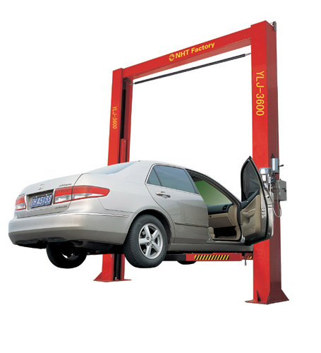
No.6 | YLJ-3600C Two Post Lift, 4Tons  With asymmetrical Lifting arms, 4.0 tons  FOB Dalian Container Price: USD1044  FOB Dalian Sample Price: USD1097  Specifications:  1. Lifting Capacity: 4000Kg  2. Post Height:3606mm  3. Lifting Height: 1800mm  4. Minimum height: 120mm  5. Clearance between posts: 2794mm  6. Total width: 3420mm  7. Lifting Time: 40s (Adjustable)  8. Lowering Time: 30s (Adjustable)  9. Voltage: 110V/220V/380V/415V, 1ph/3ph  10. Motor Power: 2.2Kw  11. Noise: <70dB  12. Net Weight: 800Kg  Gross Weight: 850Kg  13. Cubic Meter: 1.28cbm  14. Shipping: 24 pieces / 20’ container | 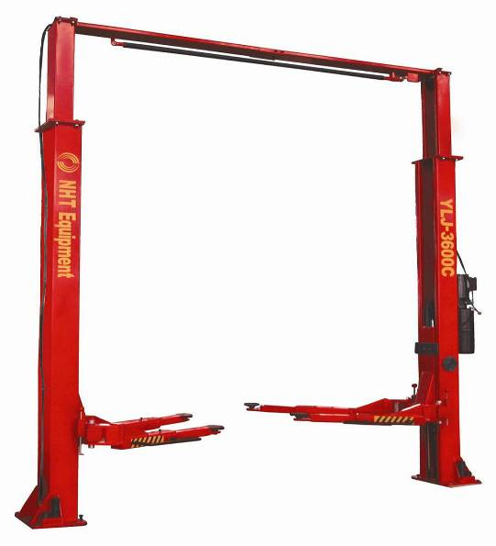
No.7 | YLJ-4000 Two Post Lift, 4Tons  With asymmetrical Lifting arms, 4.0 tons  Specifications:  1. Lifting Capacity: 4000Kg (8800lbs)  2. Lifting Height: 1800mm  3. Overall Height: 3650mm  4. Overall Width: 3419mm  5. Lifting Time: 40s (Adjustable)  6. Lowering Time: 30s (Adjustable)  7. Clearance Between Two Columns: 2750mm  8. Voltage: 110V/220V/380V/415V, 1ph/3ph  9. Noise: <70dB  10. Packing Dimension:  2900mm*580mm*720mm  750mm*250mm*300mm  11. Cubic Meter: 1.28cbm  12. Shipping:  20 pieces / 20’ container  40 pieces / 40’ container | 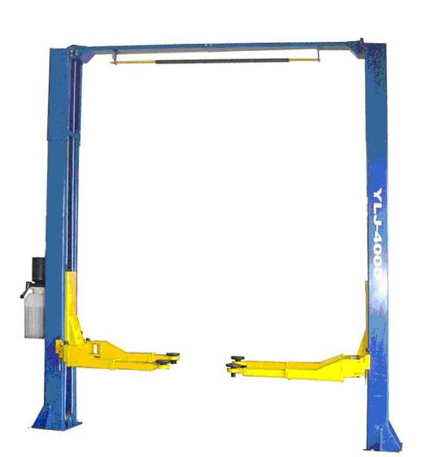
No.8 | Y4J-3500 Four post lift with Alignment Jack  With jacks/Second Hydraulic lift for wheel alignment, 3.5tons  Wheelbase 3300mm / turntable position/ slip plate  FOB Dalian Container Price: USD1680  FOB Dalian Sample Price: USD1848  Specifications:  1. Lifting Capacity: 3500Kg  2. Lifting Height:1700mm  3. Lifting Time: 40s (Adjustable)  4. Lowering Time: 30s (Adjustable)  5. Power Supply Voltage: 110V/220V/380V/415V, 1ph/3ph  6. Motor Power: 2.2Kw  7. Width Between Columns: 2850mm  8. Length of Platform: 4360mm  9. Width of Each Platform: 560mm  10. Minimum Height of Platform: 175mm  11. Net Weight: 1100Kg (2500lbs)  Gross Weight: 1200Kg  12. Packing Dimension:  Platform: 4600*600*230 2pcs  Four Poles: 2440*300*420 2pcs  Cross Rail: 3000*120*300 2pcs  Pump: 1060*290*370 1pcs  Accessories: 1180*560*320 1pcs  Jack: 960*440*380 1pcs  13. Cubic Meter:2.59cbm  14. Shipping: 9 pieces / 20’ container | 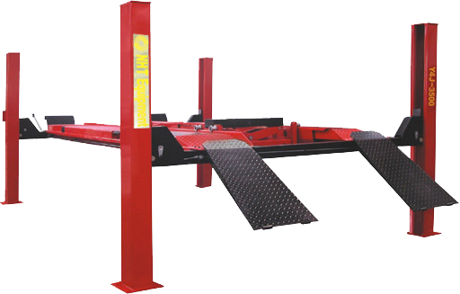
No.9 | Y4J-4000 Four Post Lift With Alignment Jack  With jacks/Second Hydraulic lift for wheel aligner, 4.0 tons  With place for Rolling Angle Plate  With safety locks  Wheelbase 3300mm / turntable position/ slip plate  FOB Dalian Container Price: USD1760  FOB Dalian Sample Price: USD1936  Specifications:  1. Lifting Capacity: 4000Kg (8800lbs)  2. Lifting Height:1962mm  3. Lifting Time: 40s (Adjustable)  4. Lowering Time: 30s (Adjustable)  5. Runaway Length: 4500mm  6. Runway Width: 508mm  7. Distance Between Runway: 1000mm  8. Voltage: 110V/220V/380V/415V, 1ph/3ph  9. Packing Dimension:  Main Body: 4720*620*770  Pump: 900*300*350  Jack: 950*570*380  10. Cubic Meter: 2.55cbm  11. Shipping: 9 pieces / 20’ container | 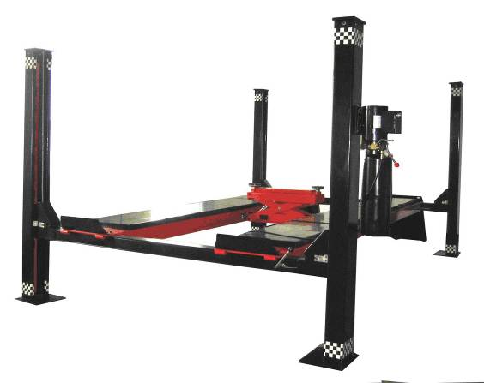
No.10 | Y4J-5500 Four Post Lift With Alignment Jack  With small lift/Second Hydraulic lift for wheel aligner 5.5 tons  Wheelbase 4300mm / turntable position/ slip plate  FOB Dalian Container Price: USD2143  FOB Dalian Sample Price: USD2250  Specifications:  1. Lifting Capacity: 5500Kg  2. Lifting Height:1850mm  3. Lifting Time: 40s (Adjustable)  4. Lowering Time: 30s (Adjustable)  5. Voltage: 110V/220V/380V/415V, 1ph/3ph  6. Motor Power: 2.2Kw  7. Width Between Columns: 2850mm  8. Length of Platform: 5170mm  9. Width of Each Platform: 560mm  10. Minimum Height of Platform: 175mm  11. Net Weight: 1250Kg Gross Weight: 1400Kg  12. Packing Dimension:  Platform: 5500*580*200 2pcs  Four Poles: 2500*320*400 2pcs  Cross Rail: 3000*270*360 2pcs  Pump: 910*300*360 1pcs  Accessories: 1080*550*300 1pcs  Jack: 960*450*380 1pcs  13. Cubic Meter: 2.94cbm  14. Shipping: 9 pieces / 20’ container | 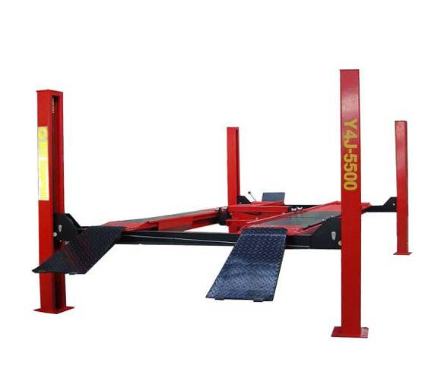
No.11 | YYJ-2800(Enlarged Size) Movable Car Lift, 3Tons  With adjustable four arms  With rubber pads for protection  With Pneumatic safety Lock  With Wheels and lifting hook for moving  FOB Dalian Container Price: USD848  FOB Dalian Sample Price: USD891  Specifications:  1. Lifting Capacity: 3000Kg  2. Max Lift Height: 1200mm  3. Minimum Height: 120mm  4. Lifting Arm Maximum Width: 1600mm  5. Lifting Arm Maximum Length: 2100mm  6. The frame width: 1200mm  7. The frame length: 1900mm  8. Lifting Time: 40s (Adjustable)  9. Lowering Time: 30s (Adjustable)  10. Noise: <70dB  11. Voltage: 110V/220V/380V/415V, 1ph/3ph  12. Motor Power: 1.5Kw  13. Net Weight: 450Kg Gross Weight: 500Kg  14. Packing Dimension:  2150mm*180mm*1330mm  1380mm*360mm*420mm  15. Cubic Meter: 0.73cbm  16. Shipping: 32 pieces / 20’ container  57 pieces / 40’ container (weight limitation) | 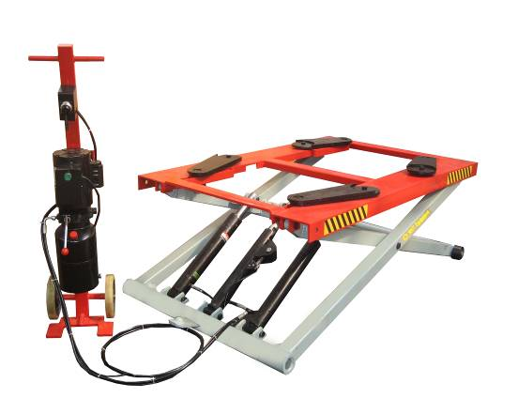
No.12 | YYJ-2800 (Standard Size, Original Design)  Movable Car Lift, 2.8Tons  With adjustable four arms  With rubber pads for protection  With Pneumatic safety Lock  With Wheels and lifting hook for moving  FOB Dalian Container Price: USD793  FOB Dalian Sample Price: USD832  Specifications:  1. Lifting Capacity: 2800Kg  2. Max Lift Height: 1200mm  3. Minimum Height: 120mm  4. Lifting Arm Maximum Width: 1400mm  5. Lifting Arm Maximum Length: 1900mm  6. The frame width: 1100mm  7. The frame length: 1700mm  8. Lifting Time: 40s (Adjustable)  9. Lowering Time: 30s (Adjustable)  10. Noise: <70dB  11. Voltage: 110V/220V/380V/415V, 1ph/3ph  12. Motor Power: 1.5Kw  13. Net Weight: 380Kg Gross Weight: 420Kg  14. Packing Dimension:  1950mm*180mm*1230mm  1380mm*360mm*420mm  15. Cubic Meter: 0.64cbm  16. Shipping: 41 pieces / 20’ container 57 pieces / 40’ container | 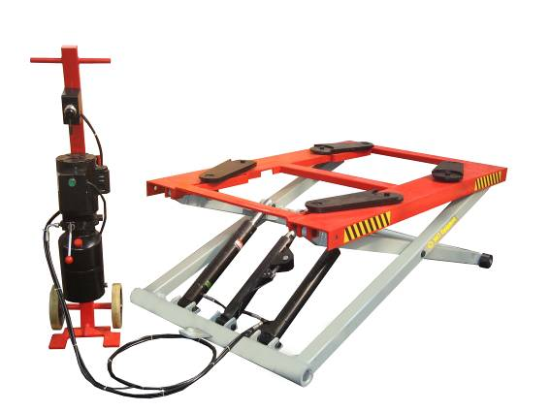
No.13 | YYJ-2800 (Reduced Size) Movable Car Lift, 2.8 Tons  With adjustable four arms  With rubber pads for protection  With Pneumatic safety Lock  Open Structure of Platform For Engine Repair  FOB Dalian Container Price: USD770  FOB Dalian Sample Price: USD809  Specifications:  1. Lifting Capacity: 2800Kg  2. Max Lift Height: 1200mm  3. Minimum Height: 120mm  4. Lifting Arm Maximum Width: 1200mm  5. Lifting Arm Maximum Length: 1900mm  6. The frame width: 900mm  7. The frame length: 1700mm  8. Lifting Time: 40s (Adjustable)  9. Lowering Time: 30s (Adjustable)  10. Noise: <70dB  11. Voltage: 110V/220V/380V/415V, 1ph/3ph  12. Motor Power: 1.5Kw  13. Net Weight: 360Kg Gross Weight: 400Kg  14. Packing Dimension:  1950mm*180mm*1030mm  1380mm*360mm*420mm  15. Cubic Meter: 0.45cbm  16. Shipping: 45 pieces / 20’ container  60 pieces / 40’ container (weight limitation) | 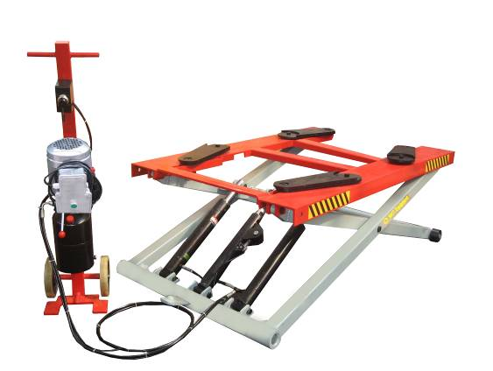
No.14 | YCJ-3000 Horizontal Scissor Lift, 3 Tons  Installed under the ground  With automatically Pneumatic safety lock  With rubber pads for protection  Electronic adjustment for two platforms of same height  FOB Dalian Container Price: USD1440  FOB Dalian Sample Price: USD1584  Specifications:  1. Lifting capacity: 3000Kg  2. Max Lifting Height: 1800mm  3. Min Hight:315mm  4. Platform Length: 1500mm  5. Single Platform Width: 500mm  6. Space Between Platforms: 900mm  7. Lifting Time: 40s (Adjustable)  8. Lowering Time: 30s (Adjustable)  9. Voltage: 110V/220V/380V/415V, 1ph/3ph  10. Noise: <70dB  11. Net Weight: 880Kg Gross Weight: 980Kg  13. Packing Dimension:  1560mm*550mm*400mm (2pcs)  520mm*380mm*1060mm (1pc)  14. Cubic Meter: 0.7cbm  15. Shipping: 20 pieces / 20’ container  42 pieces / 40’ container | 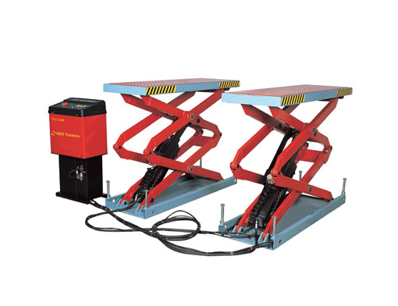
No.15 | YCJ-3000B Super Thin Scissor Lift, 3Tons  With automatically Pneumatic safety lock  With rubber pads for protection  Electronic adjustment for two platforms of same height  FOB Dalian Container Price: USD1680  FOB Dalian Sample Price: USD1848  Specifications:  1. Lifting capacity: 3000Kg  2. Lifting Height: 1850mm  3. Platform Length: 1435mm-2000mm  4. Min Height: 115mm  5. Single Platform Width: 600mm  6. Space Between Platforms: 800mm  7. Lifting Time: 40s (Adjustable)  8. Lowering Time: 30s (Adjustable)  9. Noise: <70dB  10. Voltage: 110V/220V/380V/415V, 1ph/3ph  11. Motor power: 2.2Kw  12. Net Weight: 710Kg  Gross Weight: 800Kg  13. Packing Dimension:  1660mm*720mm*270mm (2pcs)  540mm*400mm*1140mm (1pc)  1270mm*365mm*180mm (1pc)  14. Cubic Meter: 0.98cbm  15. Shipping: 24 pieces / 20’ container  48 pieces / 40’ container | 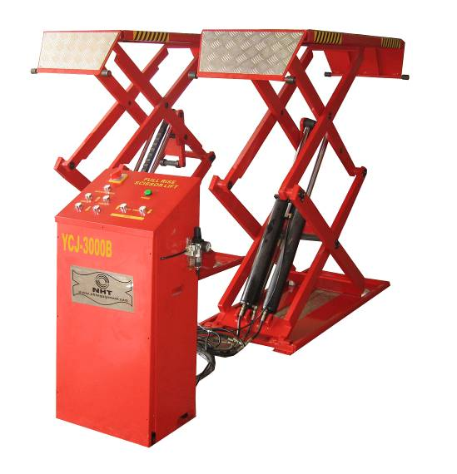
No.16 | YDJ-3000B (Fixed and with four pieces ramp), 3Tons  Super Low Scissor Lift  With automatically pneumatic safety lock  With rubber pads for protection  FOB Dalian Container Price: USD1120  FOB Dalian Sample Price: USD1232  Specifications:  1. Lifting capacity: 3000Kg  2. Max Lifting Height: 1000mm  3. Min Height: 120mm  4. Space Between Platforms: 700mm  5. Total Width: 1760mm  6. Platform Length: 1400mm-1900mm  7. Single Platform Width: 530mm  7. Lifting Time: 40s (Adjustable)  8. Lowering Time: 30s (Adjustable)  10. Voltage: 110V/220V/380V/415V, 1ph/3ph  11. Motor power: 2.2Kw  12. Noise: <70dB  13. Net Weight: 640Kg  Gross Weight: 700Kg  14. Packing Dimension:  1900mm*160mm*1560mm (1pcs)  380mm*500mm*860mm (1pc)  1000mm*350mm*200mm(4pcs)  15. Cubic Meter: 0.95cbm  16. Shipping: 30 pieces / 20’ container | 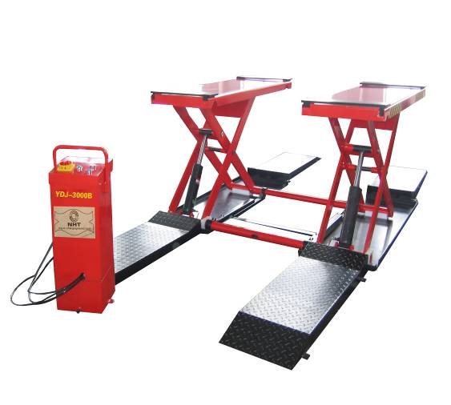
No.17 | YDJ-3000B (Movable) 3Tons  Super Low Scissor Lift  With automatically pneumatic safety lock  With rubber pads for protection  With three wheels for movement  FOB Dalian Container Price: USD960  FOB Dalian Sample Price: USD1056  Specifications:  1. Lifting capacity: 3000Kg  2. Max Lifting Height: 1000mm  3. Min Height: 120mm  4. Space Between Platforms: 700mm  5. Total Width: 1760mm  6. Platform Length: 1400mm-1900mm  7. Single Platform Width: 530mm  7. Lifting Time: 40s (Adjustable)  8. Lowering Time: 30s (Adjustable)  10. Voltage: 110V/220V/380V/415V, 1ph/3ph  11. Motor power: 2.2Kw  12. Noise: <70dB  13. Net Weight: 540Kg  Gross Weight: 600Kg  14. Packing Dimension:  1900mm*160mm*1560mm (1pcs)  380mm*500mm*860mm (1pc)  15. Cubic Meter: 0.65cbm  16. Shipping: 42 pieces / 20’ container | 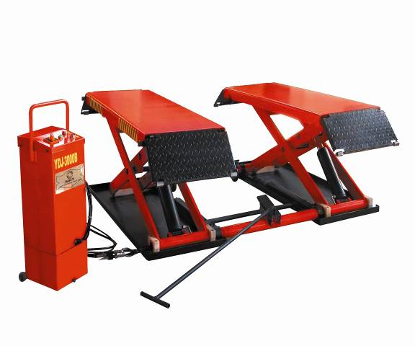
No.18 | YZJ-3500 With ramps if installation on the ground  Double-Deck Lift (For Wheel Aligner)  With automatically Pneumatic safety lock  With rubber pads for protection  Position for rolling angle plate for alignment and slip plate  Electronic adjustment for two platforms of same height  FOB Dalian Container Price: USD3040  FOB Dalian Sample Price: USD3344  Specifications:  1. Lifting Capacity: 3500Kg  2. Max lifting height (main platform with sub-platform): 2200mm  3. Main platform lifting height (sub-platform): 1750mm(450mm)  4. Clearance between platform: 930mm  5. Distance between center: 1540mm  6. Total width: 2150mm  7. Single platform total width: 600mm  8. Total length: 4400mm  7. Lifting Time: 40s (Adjustable)  8. Lowering Time: 30s (Adjustable)  11. Voltage: 110V/220V/380V/415V, 1ph/3ph  12. Motor power: 2.2Kw  13. Net Weight: 1880Kg Gross Weight: 1980Kg  14. Packing Dimension:  4100mm*820mm*550mm (2pcs)  540mm*400mm*1040mm (1pc)  15. Cubic Meter: 3.92cbm  16. Shipping: 6 pieces / 20’ container | 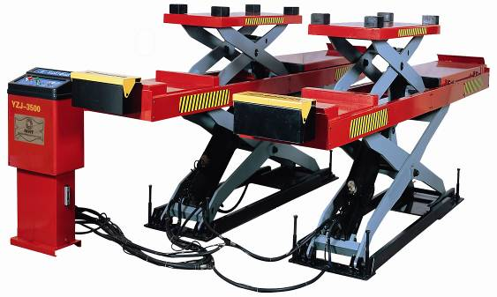
No.19 | YPJ-3600 (For Racing Car and Wheel Alignment)  With ramps if installation on the ground  With automatically Pneumatic lock  With rubber pads for protection  Position for rolling angle plate and slip plate for alignment  Electronic adjustment for two platforms of same height  FOB Dalian Container Price: USD3120  FOB Dalian Sample Price: USD3432  Specifications:  1. Lift weight: Main platform: 3600kg  2. The second lift: 1800kg/Jack  3. Lift height: Main platform: 1750mm  4. The second lift: 450mm  5. The lowest height: 430mm  6. Rise time: 40s Descent time: 30s  7. Platform total length: 4500mm  8. Max. travel distance of the second lift: 3100mm  9. Total width: 2000mm  10. Distance between two platforms: 840mm  11. Center distance between two platforms: 1420mm  12. Each platform width: 510mm  13. Voltage: 110V220V/380V/415V, 1ph/3ph  14. Motor power: 2.2Kw  15. Net Weight: 1880Kg Gross Weight: 1950Kg  16. Cubic Meter: 3.29cbm  17. Shipping: 6 pieces / 20’ container | 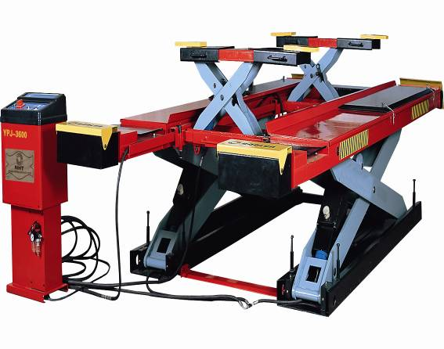
No.20 | M-500 Motorcycle Lift  (Powered by Air Compressor)  Air Pressure Clamp for front wheel  Foot Pedal for control  FOB Dalian Container Price: USD484  FOB Dalian Sample Price: USD508  Specifications:  1. Lifting Capacity: 400Kg (880lbs)  2. Max Lift Height: 700mm  3. Minimum Height: 160mm  4. Lifting Time: 20s-40s  5. Lowering Time: 20s-40s  6. Platform Length: 2200mm  7. Platform Width: 750mm  8. Air Pressure: 0.8-1.0MPa  9. Net Weight: 180Kg  Gross Weight: 200Kg  10. Packing Dimension:  2210mm*780mm*280mm  450mm*450mm*200mm  11. Cubic Meter: 0.52cbm  12. Shipping: 49 pieces / 20’ container  98 pieces / 40’ container | 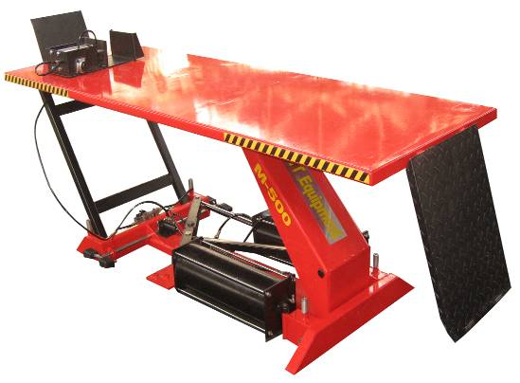
No.21 | M-500B Motorcycle Lift  (Powered by Air Compressor)  Pneumatic Control and Pneumatic clamp for front wheel on the platform  FOB Dalian Container Price: USD492  FOB Dalian Sample Price: USD516  Specifications:  1. Lifting Capacity: 400Kg(880lbs)  2. Lifting Height: 700mm  3. Minimum Height: 200mm  4. Lifting Time: 20s-35s  5. Lowering Time: 20s-35s  6. Air Pressure: 0.8-1.2MPa  7. Platform Length: 1800mm  8. Platform Width: 560mm  9. Net Weight: 128Kg  Gross Weight: 148Kg  10. Packing Dimension:  1820mm*600mm*260mm  450mm*450mm*200mm  11. Cubic Meter: 0.32cbm  12. Shipping: 63 pieces / 20’ container  133 pieces / 40’ container | 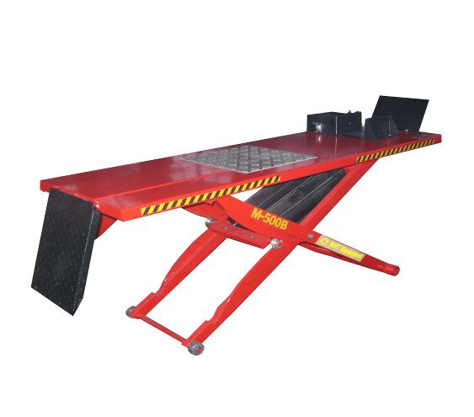
No.22 | M-500C (Powered by Air Compressor)  Motorcycle/ATV/Scooter Lift  Pneumatic Control with foot pedal  Manual clamp for front wheel  Special Steel Plates with flower pattern  Service Jack included  Thick cylinder for 500Kg lifting capacity  FOB Dalian Container Price: USD615  FOB Dalian Sample Price: USD645  Specifications:  1. Lifting Capacity: 500Kg  2. Lifting Height: 750mm  3. Minimum Height: 200mm  4. Air Pressure: 0.8-1.0MPa  5. Platform Length: 2125mm/2450mm  6. Platform Width: 600mm/1200mm  7. Net Weight: 350Kg  Gross Weight: 380Kg  8. Packing Dimension:  2200mm*690mm*500mm  9. Cubic Meter: 0.95cbm  10. Shipping: 32 pieces / 20’ container  64 pieces / 40’ container | 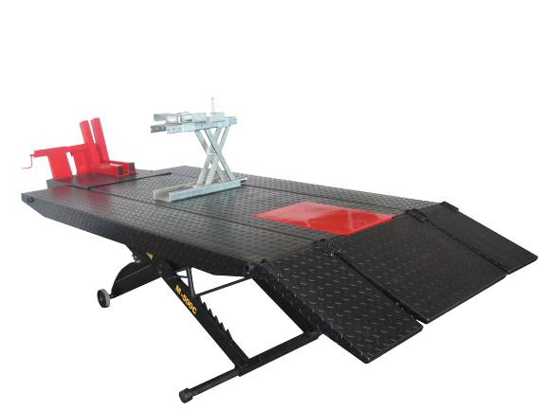
No.23 | YDJK-2000 Single Post Lift, 2Tons  Post can be left side or right side  New Parking Lift for Two Vehicles  With Flat Oil Tray Between Two Platform  FOB Dalian Container Price: USD1767  FOB Dalian Sample Price: USD1856  Specifications:  1. Lifting Capacity: 2000Kg (4400lbs)  2. Platform Length: 3860mm  3. Platform Width: 920-1960mm  4. Overall Length: 4210mm  5. Overall Width: 2650mm  6. Overall Height: 2830mm  7. Lifting Time: 30s  8. Voltage: 220V/380V 50/60Hz 1ph/3ph  9. Netwet:1250Kg Gross Weight:1300kg  10. Packing Dimension:  2900mm*640mm*400mm(1pc)  4000mm*730mm*500mm(1pc)  1850mm*800mm*200mm(1pc)  1420mm*1000mm*120mm(1pc)  1200mm*500mm*150mm(1pc)  2300mm*450mm*230mm(2pc)  11. Cubic Meter: 3.23cbm  12. Shipping: 12 pieces / 20’ container | 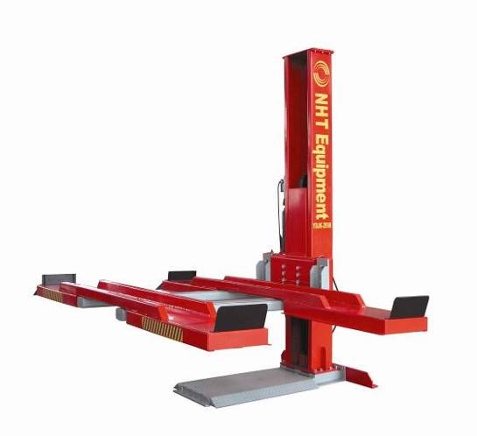
No.24 | YSJK-4000 (Manual Lock), 3Tons  Parking Lift for Two Vehicles  FOB Dalian Container Price: USD1767  FOB Dalian Sample Price: USD1856  Specifications:  1. Lifting Capacity: 3000Kg  2. Lifting Height: 1850mm  3. Overall Height: 2800mm  4. Overall Width: 2600mm  5. Lifting Time(Loaded): 30s-40s  6. Distance Between Columns:2274mm  7. Runway Width: 2194mm  8. Voltage: 110V220V/380V/415V, 1ph/3ph  9. Packing Dimension:  3550*2300*400 (1pcs, platform)  3000*580*680 (1pcs, two post)  940*300*320 (1pcs, pump and other parts)  10. Netwet:1100Kg Gross Weight:1200kg  11. Cubic Meter: 4.5cbm  12. Shipping: 6 pieces / 20’ container  12 pieces / 40’ container  15 pieces / 40HQ container  - There is still space left but not enough for more YSJK-4000!  - If not separate packing for each unit then more pieces under the condition that all these lift will be sent to same place!  - To send this model mixed with other models to make use of container space is better. | 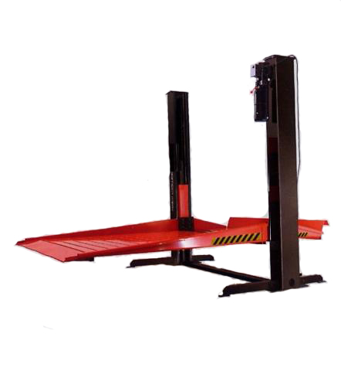
No.25 | YSJK-4000 (Electronic Control Version), 3Tons  Parking Lift for Two Vehicles  FOB Dalian Container Price: USD1896  FOB Dalian Sample Price: USD1991  Specifications:  1. Lifting Capacity: 3000Kg  2. Lifting Height: 1850mm  3. Overall Height: 2800mm  4. Overall Width: 2600mm  5. Lifting Time(Loaded): 30s-40s  6. Distance Between Columns:2274mm  7. Runway Width: 2194mm  8. Voltage: 110V220V/380V/415V, 1ph/3ph  9. Packing Dimension:  3550*2300*400 (1pcs, platform)  3000*580*680 (1pcs, two post)  940*300*320 (1pcs, pump and other parts)  10. Netwet:1100Kg Gross Weight:1200kg  11. Cubic Meter: 4.5cbm  12. Shipping: 6 pieces / 20’ container  12 pieces / 40’ container  15 pieces / 40HQ container  - There is still space left but not enough for more YSJK-4000!  - If not separate packing for each unit then more pieces under the condition that all these lift will be sent to same place!  - To send this model mixed with other models to make use of container space is better. | 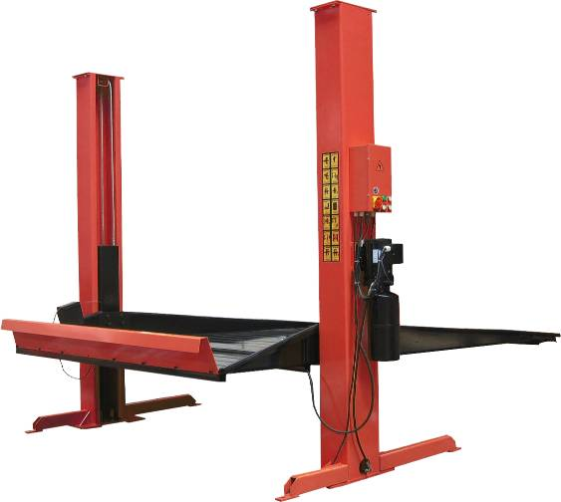
No.26 | Y4JK-3500 Parking Lift, 3.5Tons  3.5 tons Parking Lift for Two Vehicles  FOB Dalian Container Price: USD1440  FOB Dalian Sample Price: USD1584  Specifications:  1. Lifting Capacity: 3500Kg  2. Lifting Height: 1700mm-2000mm  3. Lifting Time(Loaded): 40s  4. Lowering Time(Loaded): 30s  5. Voltage: 110V220V/380V/415V, 1ph/3ph  6. Motor Power: 2.2Kw  7. Overall Height: 2450mm  8. Overall width: 3135mm  9. Length of Platform: 4500mm  10.Width of Each Platform: 560mm  11. Min Height of Platform: 175mm  12. Platform length is 4500mm and lifting capacity is 3.5 tons.  13. Packing Dimension:  Platform: 4600*600*230 2pcs  Four Poles: 2440*300*420 2pcs  Cross Rail: 3000*120*300 2pcs  Pump: 1060*290*370 1pcs  Accessories: 1180*560*320 1pcs  Oil Tray: 680*1000*290 1pcs  14. Cubic Meter: 2.59cbm  15. Shipping: 9 pieces / 20’ container  18 pieces / 40’ container | 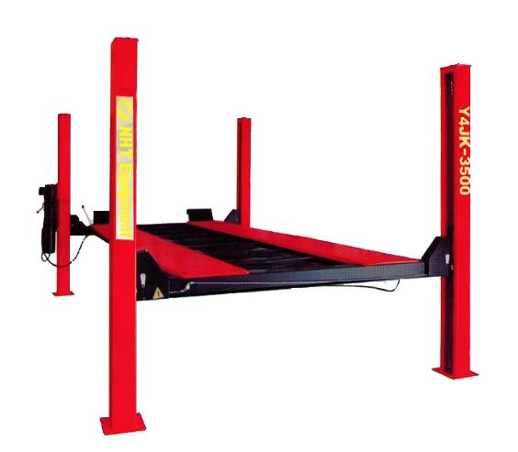
No.27 | Y4JK-5500 Parking Lift, 5.5Tons  5.5 tons Parking Lift for Two Vehicles  FOB Dalian Container Price: USD1760  FOB Dalian Sample Price: USD1936  Specifications:  1.Lifting Capacity: 5500Kg  2. Lifting Height: 1700mm-2000mm  3. Lifting Time(Loaded): 40s  4. Lowering Time(Loaded): 30s  5. Voltage: 110V220V/380V/415V, 1ph/3ph  6. Motor Power: 2.2Kw  7. Overall Height: 2450mm  8. Overall width: 3135mm  9. Length of Platform: 5300mm  10. Width of Each Platform: 560mm  11. Min Height of Platform: 175mm  12. Platform length is 5300mm and lifting capacity 5.5 tons  13. Packing Dimension:  Platform: 5500*580*200 2pcs  Four Poles: 2500*320*400 2pcs  Cross Rail: 3000*270*360 2pcs  Pump: 910*300*360 1pcs  Accessories: 1080*550*300 1pcs  oil tray: 960*450*380 4pcs  14. Cubic Meter: 2.80cbm  15. Shipping: 9 pieces / 20’ container  18 pieces / 40’ container | 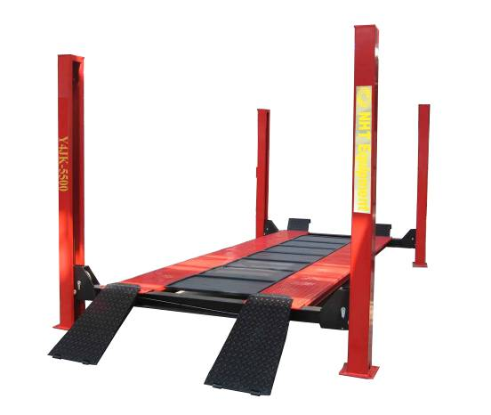
Wheel Balancers Catalogue
No. 1 | NHT250 With single protection hood  Automatic Measurement Mode  FOB Dalian Container Price: USD537  FOB Dalian Sample Price: USD564  Specifications:  1. Cycle Time: 8sec.  2. Maximum Wheel Weight: 70Kg (155lbs)  3. Motor Power: 180W-320W  4. Voltage: 110V/220V; 50Hz/60Hz  5. Balancing Speed:≤200rpm  6. Balancing Precision:±1g  7. Rim Diameter: 10"-24" (265mm-615mm)  8. Rim Width: 1.5"-20" (40mm-510mm)  9. Automatic START/STOP  10. Automatic distance/ wheel diameter measuring  11. Changeable between gram and ounce  12. Changeable between millimeter and inch  13. 4 ALU functions for light alloy wheels  14. Full screen display for the a.b.d.reading  15. Net Weight: 97Kg Gross Weight: 130Kg  16. Packing Dimension:1145mm*780mm*1140mm  17. Shipping: 30 pieces / 20’ container  60 pieces / 40’ container | 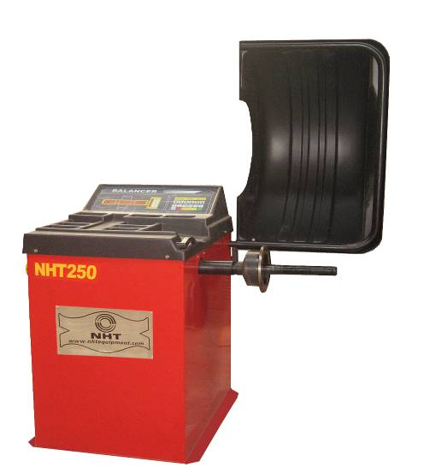
No. 2 | NHT251 With single protection hood  Semi-Automatic Measurement Mode  FOB Dalian Container Price: USD464  FOB Dalian Sample Price: USD487  Specifications:  1. Cycle Time: 8sec.  2. Maximum Wheel Weight: 70Kg (155lbs)  3. Motor Power: 180W-250W  4. Voltage: 110V/220V, 50Hz/60Hz  5. Balancing Speed:≤200rpm  6. Balancing Precision:±1g  7. Rim Diameter: 10"-24" (265mm-615mm)  8. Rim Width: 1.5"-20" (40mm-510mm)  9. Noise: <70dB  10. Technical Features:  Automatic START/STOP  Automatic distance/ wheel diameter measuring  Self calibration  Changeable between gram and ounce  Changeable between millimeter and inch  4ALU functions for light alloy wheels  Full screen display for the a.b.d.reading  11. Net Weight: 97Kg Gross Weight: 130Kg  12. Packing Dimension:1145mm*780mm*1140mm  13. Cubic Meter: 1.02cbm  14. Shipping: 30 pieces / 20’ container  60 pieces / 40’ container | 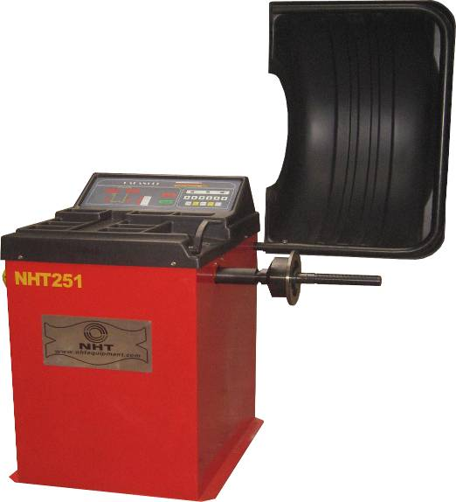
No. 3 | NHT260 With single protection hood  Automatic Measurement Mode  FOB Dalian Container Price: USD531  FOB Dalian Sample Price: USD557  Specifications:  1. Cycle Time: 8sec.  2. Maximum Wheel Weight: 70Kg (155lbs)  3. Motor Power: 180W-320W  4. Voltage: 110V/60Hz 220V/50Hz  5. Balancing Speed:≤200rpm  6. Balancing Precision: ±1g  7. Rim Diameter: 10"-24" (265mm-615mm)  8. Rim Width: 1.5"-20" (40mm-510mm)  9. Noise: <70dB Ambient: 0-40 centigrade  10. Technical Features:  Automatic START/STOP  Automatic distance/wheel diameter measuring  Changeable between gram and ounce  Changeable between millimeter and inch  4ALU functions for light alloy wheels  Full screen display for the a.b.d.reading  11. Net Weight: 119Kg  Gross Weight: 160Kg  12. Packing Dimension:1175mm*780mm*1270mm  13. Cubic Meter: 1.16cbm  14. Shipping: 30 pieces / 20’ container  60 pieces / 40’ container | 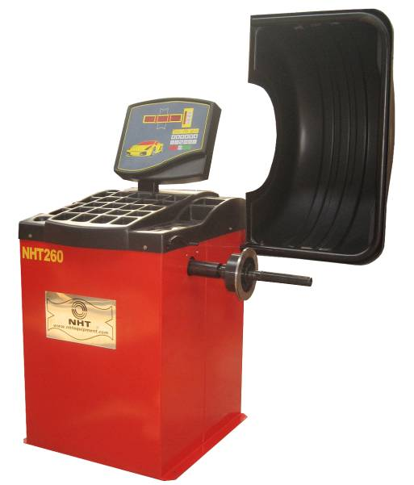
No. 4 | NHT263 With single protection hood  Automatic Measurement Mode  FOB Dalian Container Price: USD503  FOB Dalian Sample Price: USD528  Specifications:  1. Cycle Time: 8sec.  2. Maximum Wheel Weight: 70Kg (155lbs)  3. Motor Power: 180W-320  4. Power Supply Voltage: 110V/60Hz 220V/50Hz  5. Balancing Speed:≤200rpm  6. Balancing Precision: ±1g  7. Rim Diameter: 10"-24" (265mm-615mm)  8. Rim Width: 1.5"-20" (40mm-510mm)  9. Noise: <70dB Ambient: 0-40 centigrade  10. Technical Features:  Automatic START/STOP  Automatic distance/wheel diameter measuring  Changeable between gram and ounce  Changeable between millimeter and inch  4ALU functions for light alloy wheels  Full screen display for the a.b.d.reading  11. Net Weight: 119Kg Gross Weight: 160Kg  12. Packing Dimension:1175mm*780mm*1270mm  12. Cubic Meter: 1.16cbm  14. Shipping: 15 pieces / 20’ container  30 pieces / 40’ container  50 pieces / 40’ HQ container | 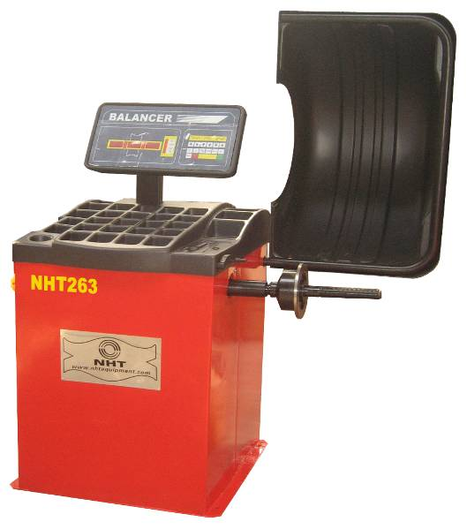
No.5 | NHT266 Monitor Type With single protection hood  Automatic Measurement Mode / Four language available  FOB Dalian Container Price: USD803  FOB Dalian Sample Price: USD843  Specifications:  1. Cycle Time: 6sec.  2. Maximum Wheel Weight: 70Kg (155lbs)  3. Motor Power: 600W  4. Voltage: 110V/220V, 50Hz/60Hz  5. Balancing Speed: ≤200rpm  6. Balancing Precision: ±1g  7. Rim Diameter: 10"-24" (265mm-615mm)  8. Rim Width: 1.5"-20" (40mm-510mm)  9. Noise: <70dB  10. Ambient: 0-40 centigrade  11. Technical Features:  Automatic START/STOP  Automatic distance/wheel diameter measuring  Self calibration  Changeable between gram and ounce  Changeable between millimeter and inch  Color video display  11. Net Weight: 120Kg  Gross Weight: 160Kg  12. Packing Dimension:1175mm*780mm*1270mm  13. Cubic Meter: 1.17cbm  14. Shipping: 30 pieces / 20’ container | 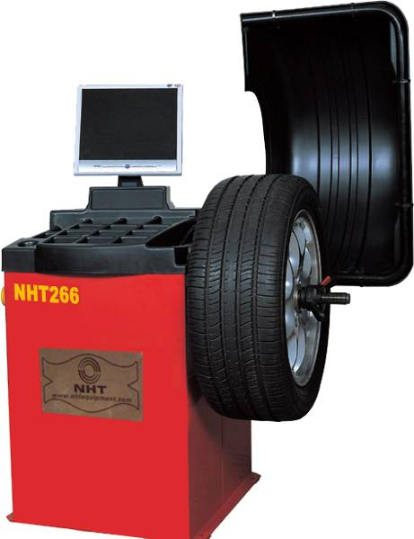
No.6 | NHT268 With single protection hood  Automatic Measurement Mode  FOB Dalian Container Price: USD521  FOB Dalian Sample Price: USD547  Specifications:  1. Cycle Time: 8sec.  2. Maximum Wheel Weight: 70Kg (155lbs)  3. Motor Power: 180W-370W  4. Power Supply Voltage: 110V/60Hz 220V/50Hz  5. Balancing Speed:≤200rpm  6. Balancing Precision:±1g  7. Rim Diameter: 10"-24" (265mm-615mm)  8. Rim Width: 1.5"-20" (40mm-510mm)  9. Noise: <70dB  10. Technical Features:  Automatic START/STOP  Automatic distance and wheel diameter measuring  Self calibration  Changeable between gram and ounce  Changeable between millimeter and inch  4ALU functions for light alloy wheels  Full screen display for the a.b.d.reading  11. Net Weight: 105Kg Gross Weight: 137Kg  12. Packing Dimension:1155mm*780mm*1450mm  13. Cubic Meter: 1.31cbm  14. Shipping: 36 pieces / 20’ container | 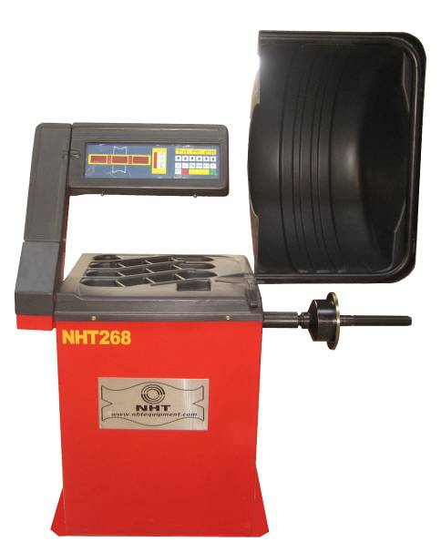
No.7 | NHT280 Automatic Measurement Mode  Monitor Type With single protection hood  English, Italian, Spanish, French Language  FOB Dalian Container Price: USD761  FOB Dalian Sample Price: USD799  Specifications:  1. Cycle Time: 10sec.  2. Maximum Wheel Weight: 70Kg (155lbs)  3. Motor Power: 600W  4. Voltage: 110V/220V, 50Hz/60Hz  5. Balancing Speed: ≤200rpm  6. Balancing Precision: ±1g  7. Rim Diameter: 10"-24" (265mm-615mm)  8. Rim Width: 1.5"-20" (40mm-510mm)  9. Noise: <70dB  10. Ambient: 0-40 centigrade  11. Technical Features:  Automatic START/STOP  Automatic distance/wheel diameter measuring  Self calibration  Changeable between gram and ounce  Changeable between millimeter and inch  4 ALU functions for light alloy wheels  Color video display  11. Net Weight: 120Kg  Gross Weight: 160Kg  12. Packing Dimension:1175mm*780mm*1270mm  13. Cubic Meter: 1.17cbm  14. Shipping: 30 pieces / 20’ container | 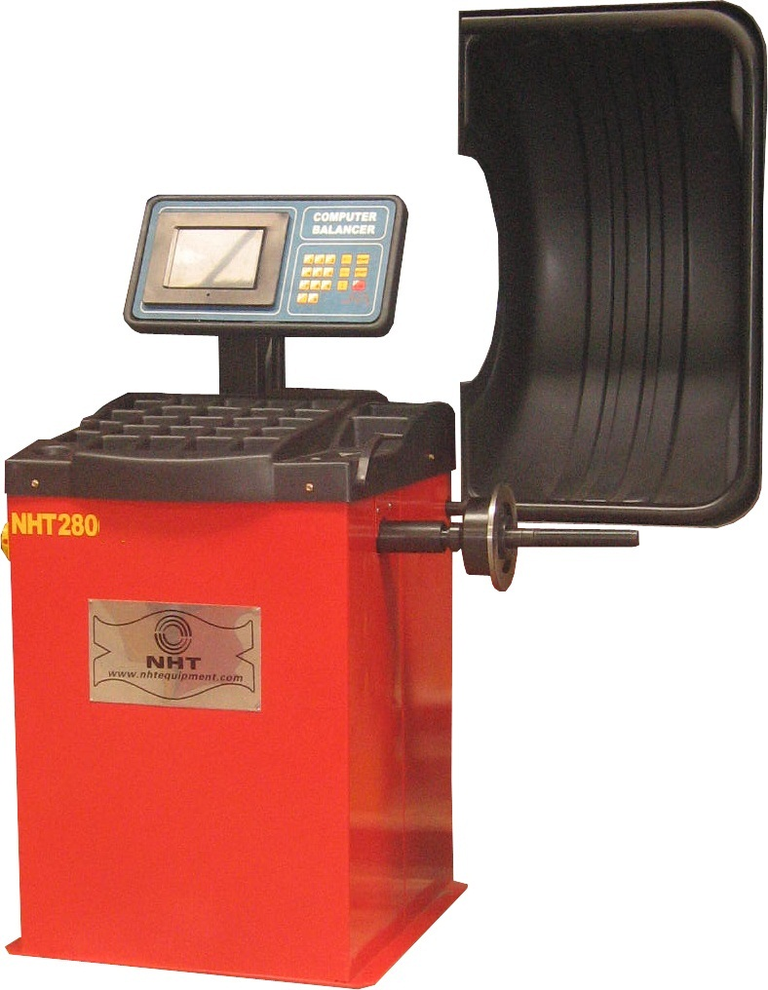
No.8 | NHT230-1 for truck and car wheel With split protection hood  FOB Dalian Container Price: USD838  FOB Dalian Sample Price: USD880  Specifications:  1. Cycle Time: 8sec.  2. Maximum Wheel Diameter: 1300mm (51" )  3. Maximum Wheel Weight: 150Kg (330lbs)  4. Voltage: 220V/380V 50/60HZ 1ph/3ph  5. Balancing Speed: ≤200rpm  6. Balancing Precision: ±1g/±5g  7. Rim Diameter: 13"-24" (330mm-609mm)  8. Rim Width: 1.5"-20" (40mm-510mm)  9. Work Air Pressure: 8-10bar  10. Technical Features:  Automatic START/STOP  Automatic distance/ wheel diameter measuring  Self calibration  Changeable between gram and ounce  Changeable between millimeter and inch  4 ALU functions for light alloy wheels  Full screen display for the a.b.d.reading  11. Net Weight: 291Kg Gross Weight: 358Kg  12. Packing Dimension:  1090mm*885mm*1460mm and915mm*520mm*1190mm  13. Cubic Meter: 1.93cbm  14. Shipping: 12 pieces / 20’ container | 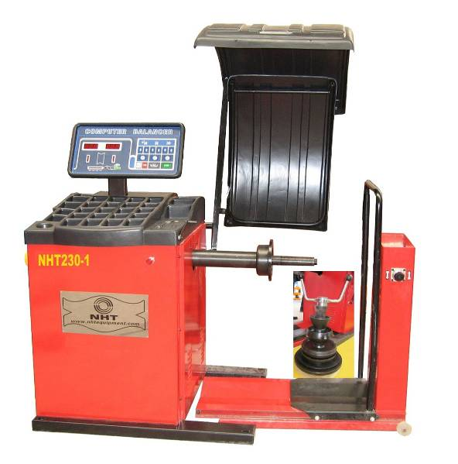
Tyre Changer Catalogue
No. 1 | NHT810 Semi-Automatic Motorcycle Tyre Changer  FOB Dalian Container Price: USD494  FOB Dalian Sample Price: USD518  Specifications:  1. Rim Clamping From Outside: 150mm-535mm (6″- 21″)  2. Max Tyre Diameter: 940mm (37″)  3. Max Tyre Width: 255mm (10″)  4. Force of Bead Breaker Blade  at Compressed Air Pressure of 1MPa : 2500Kg  5. Working Pressure: 0.8-1.0MPa(110-147Psi)  6. Voltage: 110V/220V(1ph) 380V (3ph)  7. Motor Power: 0.75Kw/1.1Kw  8. Max Rotation Torque of Turntable: 110kgm  9. Noise: <70dB  10. Net Weight: 164Kg  Gross Weight: 200Kg  11. Packing Dimension:  1000mm*760mm*940mm  12. Cubic Meter: 0.70cbm  13. Shipping: 34 pieces / 20’ container  70 pieces / 40’ container | 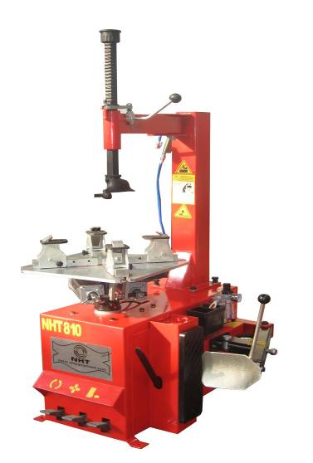

No. 2 | NHT821 car tire changer Semi-Automatic Car  FOB Dalian Container Price: USD546  FOB Dalian Sample Price: USD574  Specifications:  1.External Locking Rim Dimensions: 254mm-510mm (10″- 20″)  2. Internal Locking Rim Dimensions: 305mm-559mm (12″- 22″)  3. Max Tyre Diameter: 960mm  4. Max Tyre Width: (3’’-15’’)  5. Bead Breaker Force (10bar) : 2500Kg  6. Working Pressure: 8-10bar(116-145Psi)  7. Voltage: 110V/220V (1ph), 380V (3ph)  8. Motor Power: 0.75Kw-1.1Kw  9. Noise: <70dB  19. Technical features:  11. Pneumatic Bead Breaker blade  12. Manometer for inflating pressure control equipped with  deflating push button  13. Water box in case  14. Net Weight: 170Kg  Gross Weight: 210Kg  15. Packing Dimension:  970mm*760mm*900mm  16. Cubic Meter: 0.83 cbm  17. Shipping: 34 pieces / 20’ container  72 pieces / 40’ container | 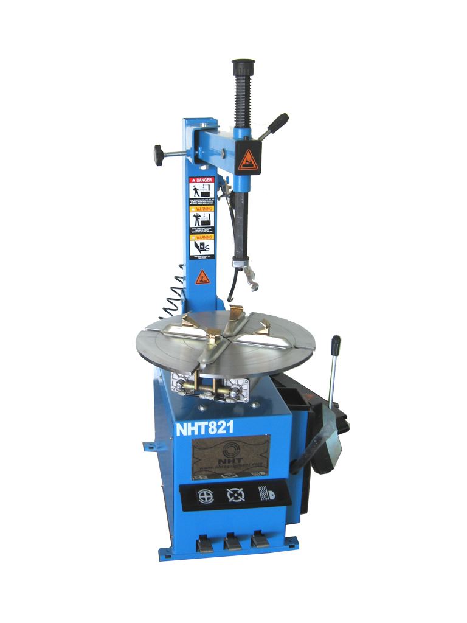
NO.3 | NHT680 Automatic car tire changer  With Inclinable post  FOB Dalian Container Price: USD620  FOB Dalian Sample Price: USD688  Specifications:  1.External Locking Rim Dimensions: 254mm-510mm (10″- 20″)  2. Internal Locking Rim Dimensions: 305mm-559mm (12″- 22″)  3. Max Tyre Diameter: 1040mm  4. Max Tyre Width: 3’’-15’’  5. Bead Breaker Force (10bar) : 2500Kg  6. Working Pressure: 8-10bar(116-145Psi)  7. Voltage: 110V/220V (1ph), 380V (3ph)  8. Motor Power: 0.75Kw-1.1Kw  9. Noise: <70dB  10. Technical features:  11. Pneumatic Bead Breaker blade  12. Manometer for inflating pressure control equipped with  deflating push button  13. Water box in case  14. Net Weight: 170Kg  Gross Weight: 210Kg  15. Packing Dimension:  1150mm*820mm*970mm  16. Cubic Meter: 0.83 cbm  17. Shipping: 28 pieces / 20’ container  48 pieces / 40’ container | 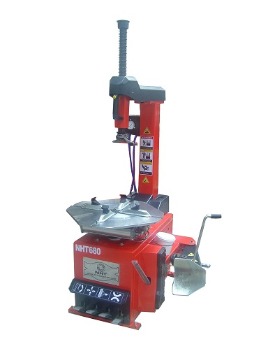
No. 4 | NHT822 Automatic Car Tyre Changer  With Inclinable post  FOB Dalian Container Price: USD692  FOB Dalian Sample Price: USD768  Specifications:  1. External Locking Rim Dimensions: 279mm-535mm(11’’-21’’)  2.Internal Locking Rim Dimensions: 330mm-610mm (13’’-24’’)  3. Max Tyre Diameter: 1100mm  4. Max Tyre Width: 350mm  5. Max. Rotation Torque of Turntable: 1100 N·m  6. Force on Bead Breaker Blade(10bar) : 2500Kg  7. Working Pressure: 0.8Mpa  8. Voltage: 110V/220V (1ph) 380V (3ph)  9. Motor Power: 0.75Kw-1.1Kw  10. Noise: <70dB  11. Net Weight: 265KG  Gross Weight: 292Kg  12. Packing Dimension:  1310mm*950mm*1020mm  13. Cubic Meter: 1.27cbm  14. Shipping: 20 pieces / 20’ container  40 pieces / 40’ container | 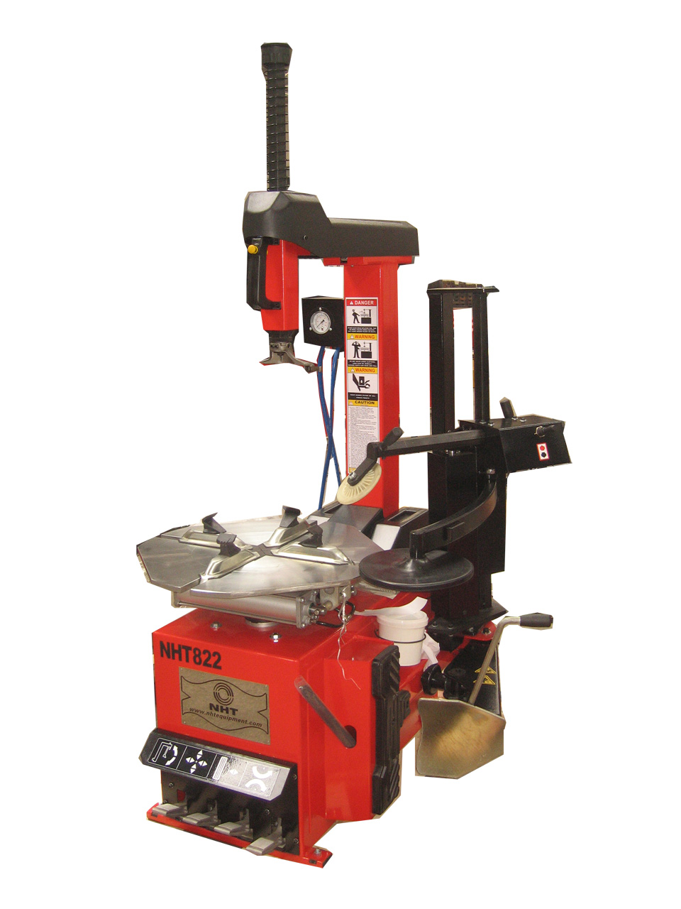
No. 5 | NHT830 Automatic Car Tyre Changer with explosive inflation  With higher machine body for tall people!  Maximum Height: 2020mm!  Round Post is Air Tank  FOB Dalian Container Price: USD753  FOB Dalian Sample Price: USD791  Specifications:  1. External Locking Rim Dimensions: 300mm-558mm (12″- 22″)  2. Internal Locking Rim Dimensions: 355mm-610mm (14″- 24″)  3. Max Tyre Diameter: 1280mm (50″)  4. Max Tyre Width: 460mm (18″)  5. Bead Breaker Force (10bar) : 2500Kg  6. Working Pressure: 8-10bar(116-145Psi)  7. Voltage: 110V/220V (1ph), 380V (3ph)  8. Motor Power: 0.75Kw-1.1Kw  9. Noise: <70dB  10. Technical features:  Pneumatic Bead Breaker blade  Manometer for inflating pressure control equipped with  deflating push button  Water box in case  11. Net Weight: 256Kg Gross Weight: 298Kg  12. Packing Dimension:  1305mm*960mm*1020mm  13. Cubic Meter: 1.30cbm  14. Shipping: 24 pieces / 20’ container  48 pieces / 40’ container | 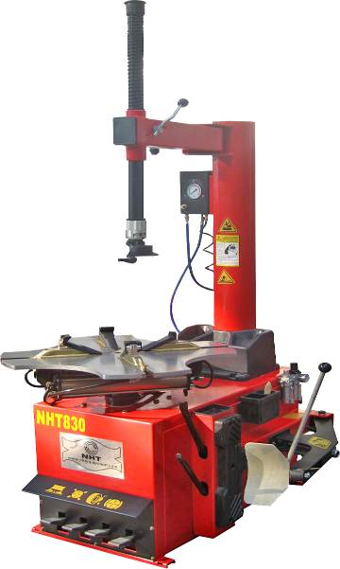
No. 6 | NHT831 Automatic Car Tyre Changer with explosive inflation  FOB Dalian Container Price: USD821  FOB Dalian Sample Price: USD912  Specifications:  1. External Locking Rim Dimensions: 254mm-510mm (10″- 22″)  2. Internal Locking Rim Dimensions: 304mm-610mm (12″- 24″)  3. Max Tyre Diameter: 1040mm  4. Max Tyre Width: 3’’-15″  5. Bead Breaker Force (10bar) : 2500Kg  6. Working Pressure: 8-10bar(116-145Psi)  7. Voltage: 110V/220V (1ph), 380V (3ph)  8. Motor Power: 0.75Kw-1.1Kw  9. Noise: <70dB  10. Technical features:  Pneumatic Bead Breaker blade  Manometer for inflating pressure control equipped with  deflating push button  Water box in case  11. Net Weight: 351Kg Gross Weight: 385Kg  12. Packing Dimension:  1250mm*900mm*1750mm  13. Cubic Meter: 1.30cbm  14. Shipping: 10 pieces / 20’ container  22 pieces / 40’ container | 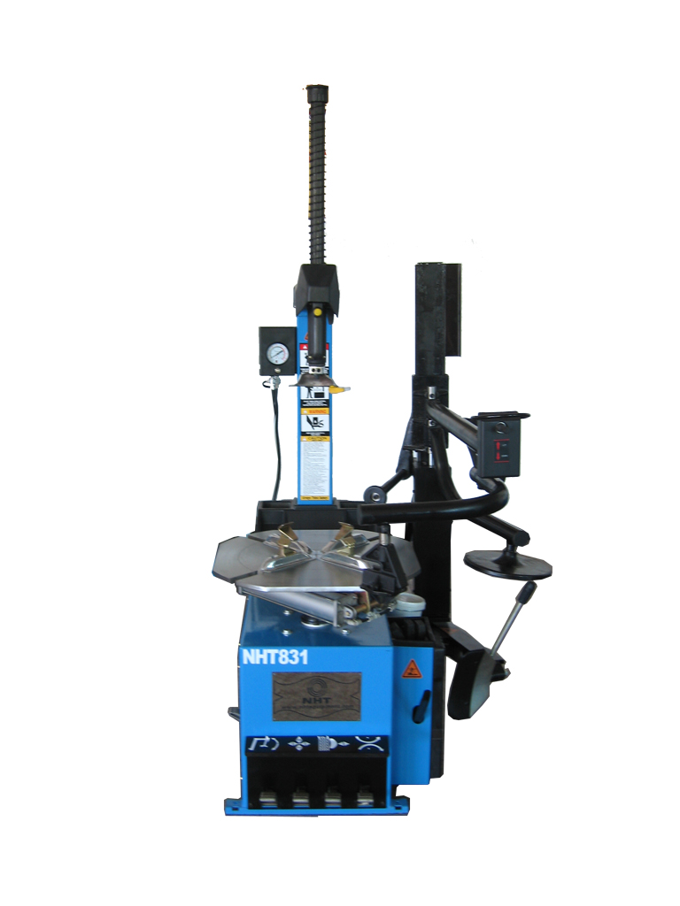
No. 7 | NHT860GT Automatic Car Tyre Changer  FOB Dalian Container Price: USD536  FOB Dalian Sample Price: USD563  Specifications:  1. External Locking Rim Dimensions: 300mm-558mm (12″- 22″)  2. Internal Locking Rim Dimensions: 355mm-610mm (14″- 24″)  3. Max Tyre Diameter: 1280mm (50″)  4. Max Tyre Width: 460mm (18″)  5. Bead Breaker Force (10bar) : 2500Kg  6. Working Pressure: 8-10bar(116-145Psi)  7. Voltage: 110V/220V (1ph), 380V (3ph)  8. Motor Power: 0.75Kw-1.1Kw  9. Noise: <70dB  10. Technical features:  Pneumatic Bead Breaker blade  Manometer for inflating pressure control equipped with  deflating push button  Water box in case  11. Net Weight: 256Kg  Gross Weight: 298Kg  12. Packing Dimension:  1305mm*960mm*1020mm  13. Cubic Meter: 1.30cbm  14. Shipping: 24 pieces / 20’ container  48 pieces / 40’ container | 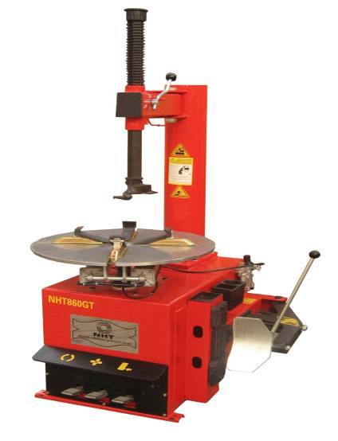
No. 8 | NHT873 Full-Automatic Car Tyre Changer  Two robotic arm  Tilting column and pneumatic locking system  FOB Dalian Container Price: USD1081  FOB Dalian Sample Price: USD1201  Specifications:  1. External Locking Rim Dimensions: 300mm-510mm (11″- 21″)  2. Internal Locking Rim Dimensions: 350mm-580mm (13″- 24″)  3. Max Tyre Diameter: 1100mm  4. Max Tyre Width:350mm  5. Working Pressure: 8-10bar(116-145Psi)  6. Voltage: 110/220V (1ph) 380V (3ph)  7. Motor Power: 0.75Kw-1.1Kw  8. Technical features:  - Self-Centering device  - Slide with step function  - The aluminum air cylinder  - Inflating control pedal at the side  - Tilting column and pneumatic locking system  9. Net Weight: 265Kg  Gross Weight: Kg  10. Packing Dimension: 1055mm*915mm*940mm  11. Cubic Meter: 0.91cbm  12. Shipping: 24 pieces / 20’ container  48 pieces / 40’ container | 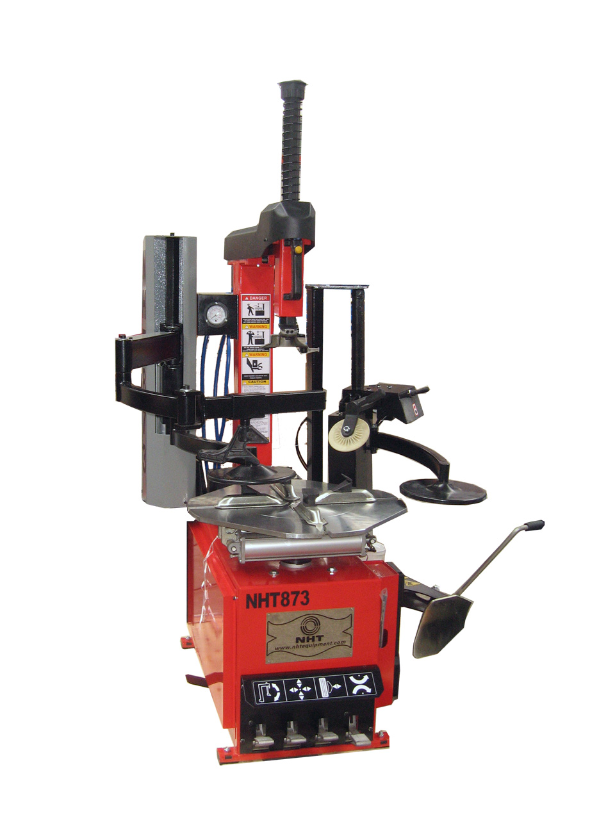
No. 9 | NHT880 Full-Automatic Car Tyre Changer  With mechanical Duck head  FOB Dalian Container Price: USD871  FOB Dalian Sample Price: USD967  Specifications:  1. Max Tyre Diameter: 1100mm  2. Max Tyre Width:350mm  3. Force on Bead Breaker Blade(10bar) : 2500Kg  4. Working Pressure: 8-10bar(116-145Psi)  5 Voltage: 110/220V (1ph) 380V (3ph)  6. Motor Power: 0.75Kw-1.1Kw  7. Noise: <70dB  8. Technical features:  - No lever, Hexangular shaft working by air pressure  - Air pressure control the mounting head rotation  - Tilting column  - Air reserve tank (Optional)  - Four set slider and auxiliary arm have double safty locking  - Bead blast inflation for special tyre (Optional)  9. Net Weight: 216Kg  Gross Weight: 256Kg  10. Packing Dimension:  1055mm*915mm*940mm  11. Cubic Meter: 0.91cbm  12. Shipping: 24 pieces / 20’ container  48 pieces / 40’ container | 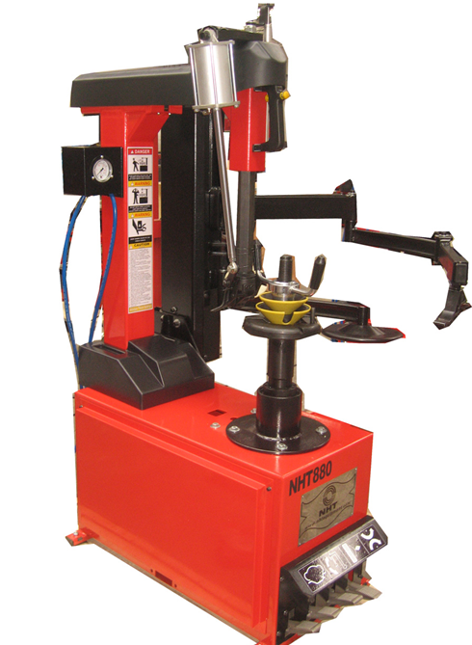
No. 10 | NHT881 Full-Automatic Car Tyre Changer/Inclinable Post  With mechanical Duck head  With plastic protection for clamp  FOB Dalian Container Price: USD908  FOB Dalian Sample Price: USD1008  Specifications:  1. External Locking Rim Dimensions: 300mm-535mm (11″- 21″)  2. Internal Locking Rim Dimensions: 350mm-610mm (13″- 24″)  3. Max Tyre Diameter: 1000 mm ( 39″)  4. Max Tyre Width: 350mm ( 16″)  5. Bead breaker Force (10bar) : 2500Kg  6. Working Pressure: 8-10bar(116-145Psi)  7. Voltage: 110/220V (1ph) 380V (3ph)  8. Motor Power: 0.75Kw-1.1Kw  9. Technical features:  Pneumatic Bead Breaker blade  Manometer for inflating pressure control equipped with deflating push button  Water box in case Pole is tiltable  10. Net Weight: 336Kg Gross Weight: 397Kg  11. Cubic Meter: 1.70cbm  12. Shipping: 13 pieces / 20’ container  26 pieces / 40’ container  29 pieces / 40HQ container | 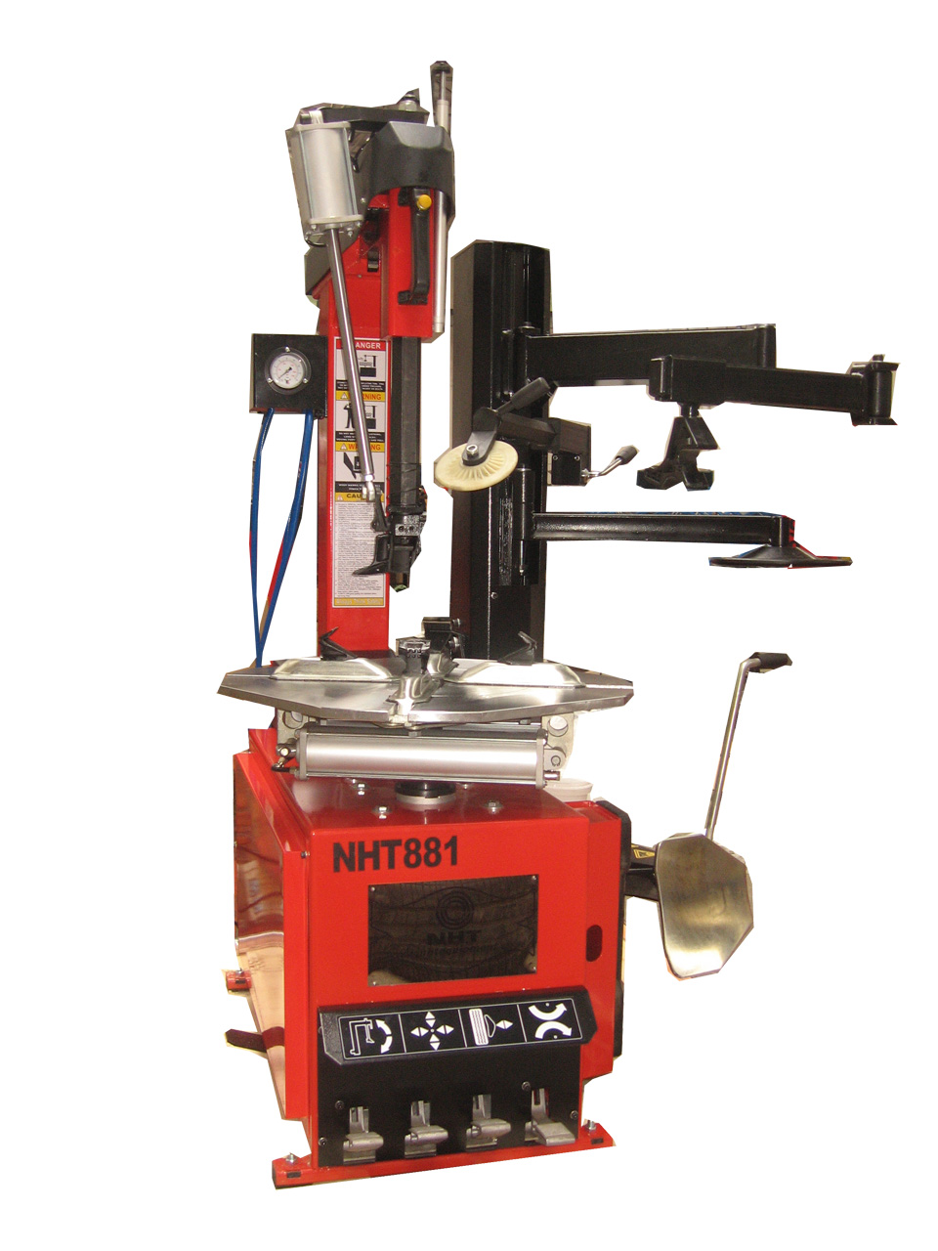
No. 11 | NHT881-2-GT Full-Automatic Tyre Changer / Inclinable Post  With Fast Changeable Duck head (Metal and Plastic)  GT Means Fast Inflation  With plastic protection for clamp  FOB Dalian Container Price: USD1342  FOB Dalian Sample Price: USD1409  Specifications:  1. External Locking Rim Dimensions: 350mm-610mm (14″- 24″)  2. Internal Locking Rim Dimensions: 400mm-710mm (16″- 28″)  3. Max Tyre Diameter: 1200mm (47″)  4. Max Tyre Width: 410mm (16″)  5. Bead breaker Force (10bar): 2500Kg  6. Working Pressure: 8-10bar(116-145Psi)  7. Voltage: 110/220V (1ph) 380V (3ph)  8. Motor Power: 0.75Kw-1.1Kw  9. Max. Rotation Torque of Turntable: 1100 N·m  10.Technical features:  The combined NHT881-2-GT is full automatic changer specially for wide tread and low-profile Tyres  Post is inclinable  Pneumatic locking for vertical shaft and moving arm  Quick Inflating and Pneumatic Bead-remove  Air-release button for pressure device  11. Net Weight: 358Kg  Gross Weight: 400Kg  12. Packing Dimension: 2.10cbm  13. Shipping: 11 pieces / 20’ container 23 pieces / 40’ container | 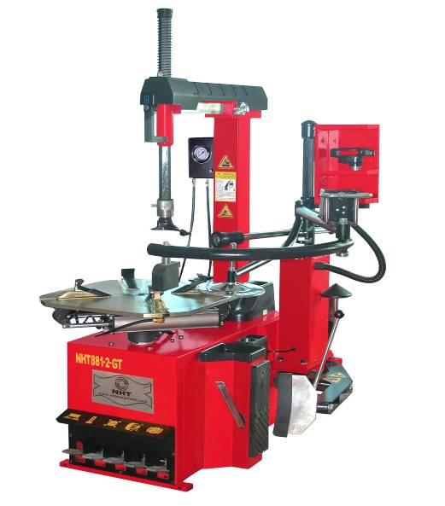
No. 12 | NHT780 Full-Automatic Car Tyre Changer/Inclinable Post  With plastic protection for clamp  FOB Dalian Container Price: USD896  FOB Dalian Sample Price: USD995  Specifications:  1. External Locking Rim Dimensions: 300mm-535mm (11″- 21″)  2. Internal Locking Rim Dimensions: 350mm-610mm (13″- 24″)  3. Max Tyre Diameter: 1000 mm ( 39″)  4. Max Tyre Width: 350mm ( 16″)  5. Bead breaker Force (10bar) : 2500Kg  6. Working Pressure: 8-10bar(116-145Psi)  7. Voltage: 110/220V (1ph) 380V (3ph)  8. Motor Power: 0.75Kw-1.1Kw  9. Technical features:  Pneumatic Bead Breaker blade  Manometer for inflating pressure control equipped with deflating push button  Water box in case Pole is tiltable  10. Net Weight: 336Kg Gross Weight: 397Kg  11. Cubic Meter: 1.70cbm  12. Shipping: 13 pieces / 20’ container  26 pieces / 40’ container  29 pieces / 40HQ container | 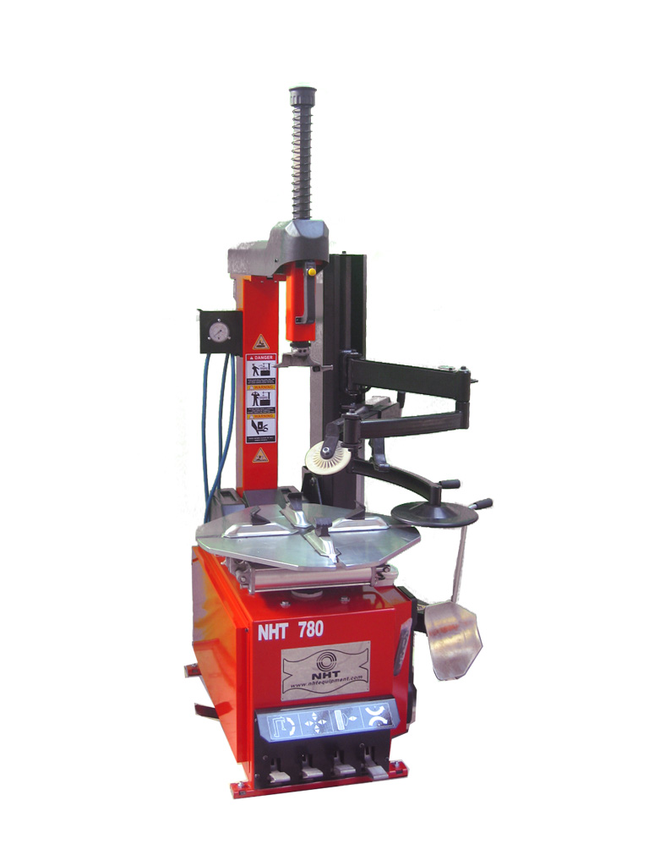

No. 13 | NHT890 Semi-automatic Tyre Changer for Truck 26Inch  Move the Tyre Hook and the Round Plate by Hand!  FOB Dalian Container Price: USD2179  FOB Dalian Sample Price: USD2288  Specifications:  1. Wheel Rim Diameter: 355mm-660mm (14"-26")  2. Max Tyre Diameter: 1600mm (60")  3. Max Tyre Width: 800mm (40")  4. Max Wheel Weight: 1270Kg  5. Motor Power: 1.1Kw-1.5Kw  6. Working Pressure: 0-13MPa  7. Voltage: 220V/1ph, 220V/3ph, 380V/3ph  8. Motor Power: 1.5Kw 2.2Kw  9. Technical features:  All movement of the working parts are guided by the movable control platform, particularly suitable for handling truck wheel, farm wheels, passenger car wheels and industrial vehicle wheels between 14" and 26" with deep grooved rims, with ring. It is an ideal mechanized equipment for maintenance wheel, for it saves time and labor with high efficiency, which does not damage to the inside of the rubber wheel and rim three oil cylinders  Moveable control platform  Working arm with quick rotation system  10. Net Weight: 590Kg Gross Weight: 720Kg  11. Packing Dimension: 2110mm*1730mm*1020mm  12. Cubic Meter: 3.72cbm  13. Shipping: 6 pieces / 20’ container Space left for other models | 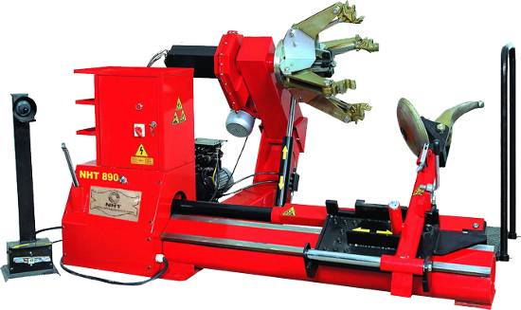
No. 14 | NHT891 Full Automatical Tyre Changer for Truck 26Inch  FOB Dalian Container Price: USD2347  FOB Dalian Sample Price: USD2464  Specifications:  1. Wheel Rim Diameter: 355mm-660mm (14"-26")  2. Max Tyre Diameter: 1600mm (60")  3. Max Tyre Width: 800mm (40")  4. Max Wheel Weight: 1270Kg  5. Motor Power: 1.1Kw-1.5Kw  6. Working Pressure: 0-13MPa  7. Voltage : 220V/1ph, 220V/3ph, 380V/3ph  8. Motor Power: 1.5Kw 2.2Kw  9. Noise: <70dB  10. Technical features:  All movement of the working parts are guided by the movable control platform, particularly suitable for handling truck wheel, farm wheels, passenger car wheels and industrial vehicle wheels between 14" and 26" with deep grooved rims, with ring. It is an ideal mechanized equipment for maintenance wheel, for it saves time and labor with high efficiency, which does not damage to the inside of the rubber wheel and rim. Full automatic control working arm lift. Movable control platform. Working arm with quick rotation system Four oil cylinder  11. Net Weight: 590Kg Gross Weight: 720Kg  12. Packing Dimension: 2260mm*1795mm*1020mm  13. Cubic Meter: 4.14cbm  14. Shipping: 6 pieces / 20’ container Space left for other models | 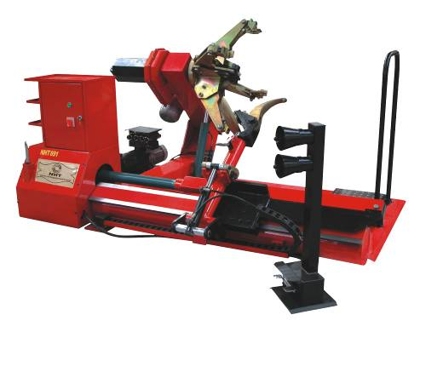
No. 15 | NHT892 Full Automatic Tyre Changer 56Inch  FOB Dalian Container Price: USD3353  FOB Dalian Sample Price: USD3521  Specifications:  1. Max Tyre Diameter:2300mm (90")  2. Handles Rim From: 350mm-1422mm (14"-56")  3. Max Tyre Width:1100mm (43")  4. Max wheel Weight:1200Kg  5. Pump Motor Power:1.5KW  6. MOTOR Power: 2.2-2.8KW, 2 speed motor with CW and CCW  7. Working Pressure:0-130Bar  8. Voltage : 220V/1ph 380V/3ph  9. Technical Features:  All movement of the working parts are guided by the movable control platform, particularly suitable for handling truck wheel, farm wheels, bus wheels and industrial vehicle wheels between 14″and 56″with deep grooved rims, with ring. It is an ideal mechanized equipment for maintenance wheel, for it saves time and labor with high efficiency, which does not damage to the inside of the rubber wheel and rim.  Full automatic control working arm lift. Movable control platform. Working arm with rotation system. Five oil cylinders.  10. Net Weight 1260Kg Gross Weight: 1300Kg  11. Packing Dimension:2310mm*2130mm*1190mm  12. Cubic Meter: 5.86cbm  13. Shipping: 4 pieces / 20’ container Space left for other models | 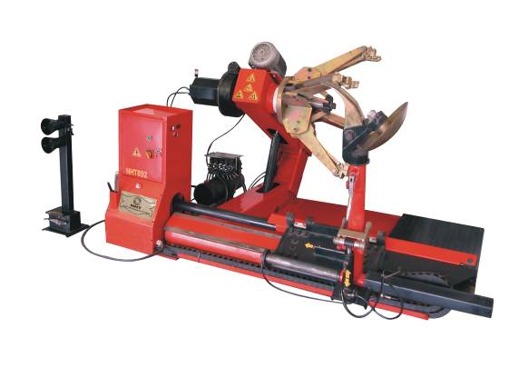
No.16 | NHT980 Full Automatic Truck Tyre Changer 56Inch  FOB Dalian Container Price: USD3529  FOB Dalian Sample Price: USD3706  Specifications:  Bidirectional Chuck with 2 Rotational Speeds  Max Wheel Diameter:2500mm (100")  Handles Rim From: 350mm-1400mm (14"-56")  Max Wheel Width:1200mm (48")  Max wheel Weight:2200Kg  Gear Box Motor:2.4KW/3.0Kw  Hydraulic Unit Motor: 2.4KW/3.0Kw  Power Supply Voltage : 230V,400V, 1ph/3ph. 50Hz/60Hz  Net Weight: 1000Kg  Gross Weight: 1200Kg  Packing Dimension:2300mm*2100mm*1300mm  Cubic Meter: 6.3cbm  Shipping: 4 pieces / 20’ container Space left for other models | 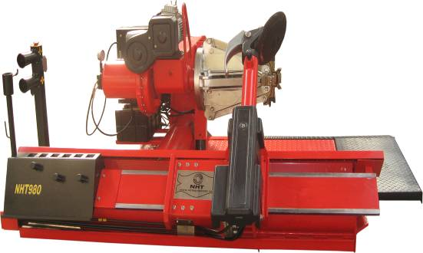

Wheel Alignments Catalogue
No.1 | NHT601 (Bluetooth Wheel Alignment)  FOB Dalian Container Price: USD3800  FOB Dalian Sample Price: USD3990  Specifications:  1. Voltage: 110V/220V  2. Rim diameter: 12"-20"  3. Toe: +8°~-8°(±0.02°)  4. Camber: +15°~-15°(±0.01°)  5. Caster: +20°~-20°(±0.04°)  6. Kingpin inclinable: +20°~-20°(±0.02°)  7. Set back: +8°~-8°(±0.02°)  8. Steering angle: +45°~-45°(±0.04°)  9. Thrust angle: +8°~-8°(±0.02°)  10. Net Weight: 195Kg  11. Testing: 8Bundle  12. Transmission: Bluetooth  13. Sensor Battery Voltage: 7.2V/5A  The Mainframe and printer:  1. Power: 0.5KW Electric voltage: 110V/220V  2. Computer: Standard HP/Dell Desktop  3. CPU: 1.8G Memory: 1GB Hard disk: 250G DVD Driver  4. Keyboard and Mouse: 1set wireless and 1set with cable  5. Monitor: HP/Dell19" LCD  6. Printer : HP-Ink-jet printer with Color  Packing Size: 1.8 Cubic Meter  900mm*860mm*1310mm (1pcs)  1050mm*850mm*890mm (1pcs) | 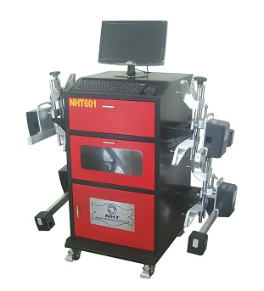
No.2 | NHT602 (Bluetooth Wheel Alignment)  FOB Dalian Container Price: USD3800  FOB Dalian Sample Price: USD3990  Specifications:  1. Voltage: 110V/220V  2. Rim diameter: 12"-20"  3. Toe: +8°~-8°(±0.02°)  4. Camber: +15°~-15°(±0.01°)  5. Caster: +20°~-20°(±0.04°)  6. Kingpin inclinable: +20°~-20°(±0.02°)  7. Set back: +8°~-8°(±0.02°)  8. Steering angle: +45°~-45°(±0.04°)  9. Thrust angle: +8°~-8°(±0.02°)  10. Net Weight: 195Kg  11. Testing: 8Bundle  12. Transmission: Bluetooth  13. Sensor Battery Voltage: 7.2V/5A  The Mainframe and printer:  1. Power: 0.5KW  2. Electric voltage: 110V/220V  3. Computer: Standard HP/Dell Desktop  4. CPU: 1.8G Memory: 1GB Hard disk: 250G DVD Driver  5. Keyboard and Mouse: 1set wireless and 1set with cable  6. Monitor: HP/Dell19" LCD  7. Printer : HP-Ink-jet printer with Color  Packing Size: 1.8 Cubic Meter  900mm*860mm*1310mm (1pcs)  1050mm*850mm*890mm (1pcs) | 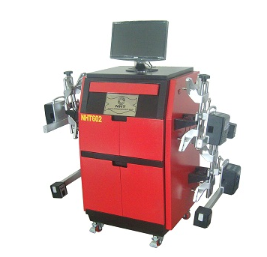
No.3 | NHT603 (Bluetooth Wheel Alignment)  FOB Dalian Container Price: USD3800  FOB Dalian Sample Price: USD3990  Specifications:  1. Voltage: 110V/220V  2. Rim diameter: 12"-20"  3. Toe: +8°~-8°(±0.02°)  4. Camber: +15°~-15°(±0.01°)  5. Caster: +20°~-20°(±0.04°)  6. Kingpin inclinable: +20°~-20°(±0.02°)  7. Set back: +8°~-8°(±0.02°)  8. Steering angle: +45°~-45°(±0.04°)  9. Thrust angle: +8°~-8°(±0.02°)  10. Net Weight: 195Kg  11. Testing: 8Bundle  12. Transmission: Bluetooth  13. Sensor Battery Voltage: 7.2V/5A  The Mainframe and printer:  1. Power: 0.5KW  2. Electric voltage: 110V/220V  3. Computer: Standard HP/Dell Desktop  4. CPU: 1.8G Memory: 1GB Hard disk: 250G DVD Driver  5. Keyboard and Mouse: 1set wireless and 1set with cable  6. Monitor: HP/Dell19" LCD  7. Printer : HP-Ink-jet printer with Color  Packing Size: 1.8 Cubic Meter  900mm*860mm*1310mm (1pcs)  1050mm*850mm*890mm (1pcs) | 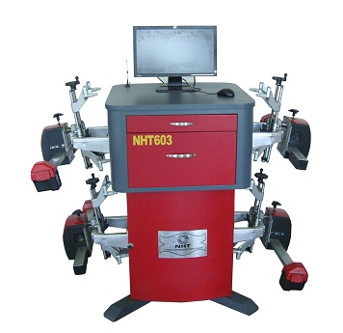
No.4 | NHT604 (Bluetooth Wheel Alignment)  FOB Dalian Container Price: USD3900  FOB Dalian Sample Price: USD4090  Specifications:  1. Voltage: 110V/220V  2. Rim diameter: 12"-20"  3. Toe: +8°~-8°(±0.02°)  4. Camber: +15°~-15°(±0.01°)  5. Caster: +20°~-20°(±0.04°)  6. Kingpin inclinable: +20°~-20°(±0.02°)  7. Set back: +8°~-8°(±0.02°)  8. Steering angle: +45°~-45°(±0.04°)  9. Thrust angle: +8°~-8°(±0.02°)  10. Net Weight: 175Kg  11. Testing: 8Bundle  12. Transmission: Bluetooth  13. Sensor Battery Voltage: 7.2V/5A  The Mainframe and printer:  1. Electric voltage: 110V/220V  2. Computer: Standard Dell Laptop  3. CPU: Intel Memory: 1GB Hard disk: 250G DVD Driver  4. Keyboard and Mouse: Wireless Mouse  5. Monitor: 14" LCD  6. Printer : HP-Ink-jet printer with Color  Packing Size: 1.20 Cubic Meter  900mm*860mm*1000mm (1pcs)  1050mm*850mm*490mm (1pcs) | 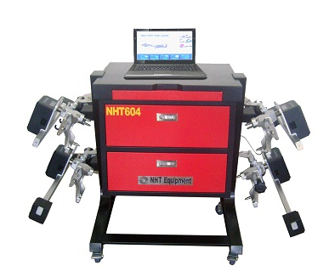
No.5 | NHT605 (Bluetooth Wheel Alignment)  FOB Dalian Container Price: USD3900  FOB Dalian Sample Price: USD4090  Specifications:  1. Voltage: 110V/220V  2. Rim diameter: 12"-20"  3. Toe: +8°~-8°(±0.02°)  4. Camber: +15°~-15°(±0.01°)  5. Caster: +20°~-20°(±0.04°)  6. Kingpin inclinable: +20°~-20°(±0.02°)  7. Set back: +8°~-8°(±0.02°)  8. Steering angle: +45°~-45°(±0.04°)  9. Thrust angle: +8°~-8°(±0.02°)  10. Net Weight: 195Kg  11. Testing: 8Bundle  12. Transmission: Bluetooth  13. Sensor Battery Voltage: 7.2V/5A  The Mainframe and printer:  1. Power: 0.5KW Electric voltage: 110V/220V  2. Computer: Standard HP/Dell Desktop  3. CPU: 1.8G Memory: 1GB Hard disk: 250G DVD Driver  4. Keyboard and Mouse: 1set wireless and 1set with cable  5. Monitor: HP/Dell19" LCD  6. Printer : HP-Ink-jet printer with Color  Packing Size: 1.5 Cubic Meter  900mm*860mm*1500mm (1pcs)  1050mm*850mm*490mm (1pcs)  Note: Laptop can be packed inside the cabinet! | 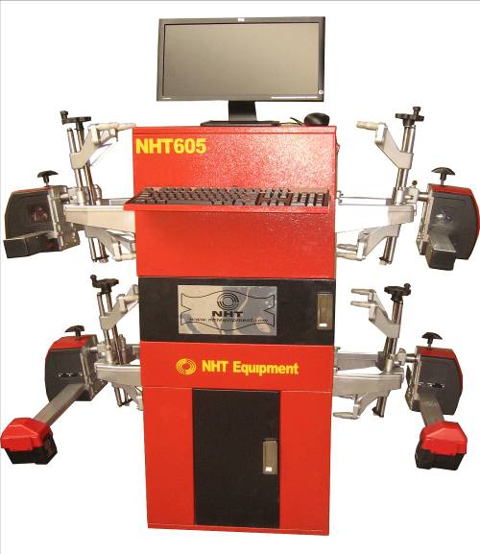
No.6 | NHT606 (Bluetooth Truck Wheel Alignment)  FOB Dalian Container Price: USD8500  FOB Dalian Sample Price: USD8700  Specifications:  1. Voltage: 110V/220V  2. Rim diameter: 16"-24"  3. Toe: +10°~-10°(±0.02°)  4. Camber: +15°~-15°(±0.01°)  5. Caster: +20°~-20°(±0.04°)  6. Kingpin inclinable: +20°~-20°(±0.02°)  7. Set back: +10°~-10°(±0.02°)  8. Steering angle: +45°~-45°(±0.04°)  9. Thrust angle: +10°~-10°(±0.02°)  10. Net Weight: 195Kg  11. Testing: 8Bundle  12. Transmission: Bluetooth  13. Sensor Battery Voltage: 7.2V/5A  The Mainframe and printer:  1. Power: 0.5KW  2. Electric voltage: 110V/220V  3. Computer: Standard HP/Dell Desktop  4. CPU: 1.8G Memory: 1GB Hard disk: 250G DVD Driver  5. Keyboard and Mouse: 1set wireless and 1set with cable  6. Monitor: HP/Dell19" LCD  7. Printer : HP-Ink-jet printer with Color  Packing Size: 1.8 Cubic Meter  900mm*860mm*1310mm (1pcs)  1050mm*850mm*890mm (1pcs) | 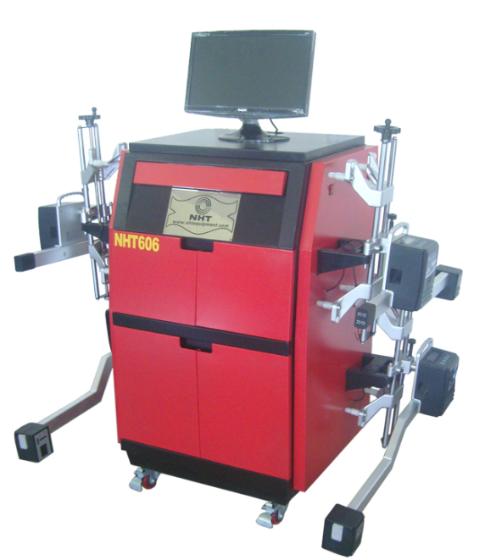

No.7 | NHT607(Bluetooth Wheel Alignment)  FOB Dalian Container Price: USD8500  FOB Dalian Sample Price: USD8700  Specifications:  1. Voltage: 110V/220V  2. Rim diameter: 12"-20"  3. Toe: +8°~-8°(±0.02°)  4. Camber: +15°~-15°(±0.01°)  5. Caster: +20°~-20°(±0.04°)  6. Kingpin inclinable: +20°~-20°(±0.02°)  7. Set back: +8°~-8°(±0.02°)  8. Steering angle: +45°~-45°(±0.04°)  9. Thrust angle: +8°~-8°(±0.02°)  10. Net Weight: 195Kg  11. Testing: 8Bundle  12. Transmission: Bluetooth  13. Sensor Battery Voltage: 7.2V/5A  The Mainframe and printer:  1. Monitor: 19" LCD  2. Printer : HP-Ink-jet printer with Color  Packing Size: 1.8 Cubic Meter  900mm*860mm*1310mm (1pcs)  1050mm*850mm*890mm (1pcs)  Shipping: 24 pieces / 20’ container  52 pieces / 40’ container | 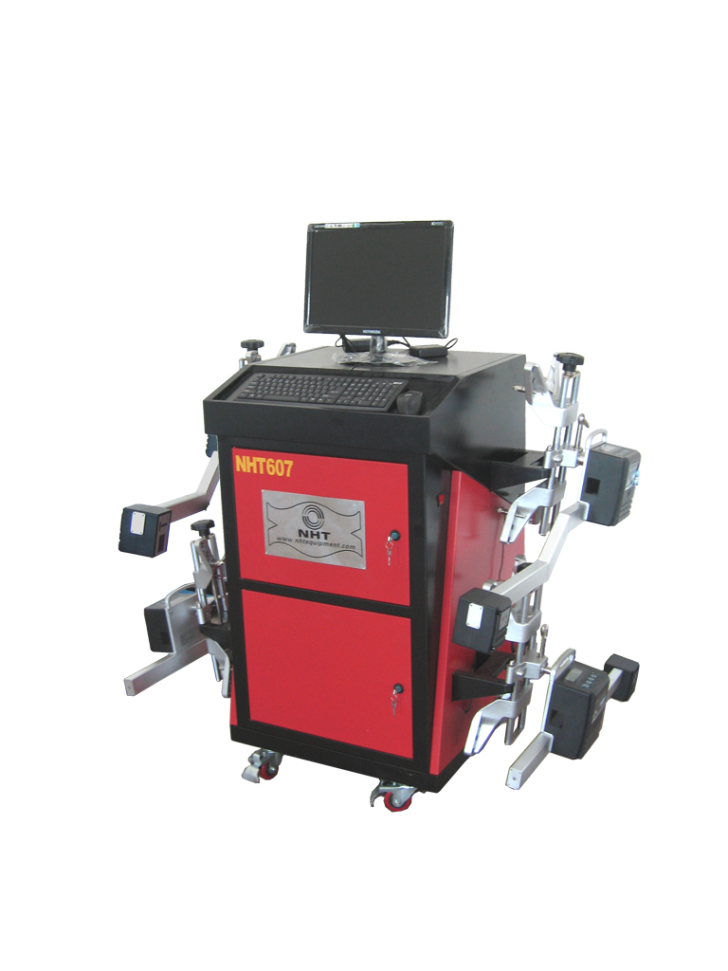
No.8 | NHT608 (Bluetooth Wheel Alignment)  FOB Dalian Container Price: USD8660  FOB Dalian Sample Price: USD8860  Specifications:  1. Voltage: 110V/220V  2. Rim diameter: 12"-24"  3. Toe: +10°~-10°(±0.02°)  4. Camber: +15°~-15°(±0.01°)  5. Caster: +20°~-20°(±0.04°)  6. Kingpin inclinable: +20°~-20°(±0.02°)  7. Set back: +6°~-6°(±0.03°)  8. Steering angle: +45°~-45°(±0.04°)  9. Thrust angle: +6°~-6°(±0.03°)  10. Net Weight: 195Kg  11. Testing: 8Bundle  12. Transmission: Bluetooth  13. Sensor Battery Voltage: 7.2V/5A  The Mainframe and printer:  1. Monitor: 19" LCD; 22”LCD  2. Printer : HP-Ink-jet printer with Color  Packing Size: 1.8 Cubic Meter  900mm*860mm*1310mm (1pcs)  1050mm*850mm*890mm (1pcs)  Shipping: 24 pieces / 20’ container  52 pieces / 40’ container | 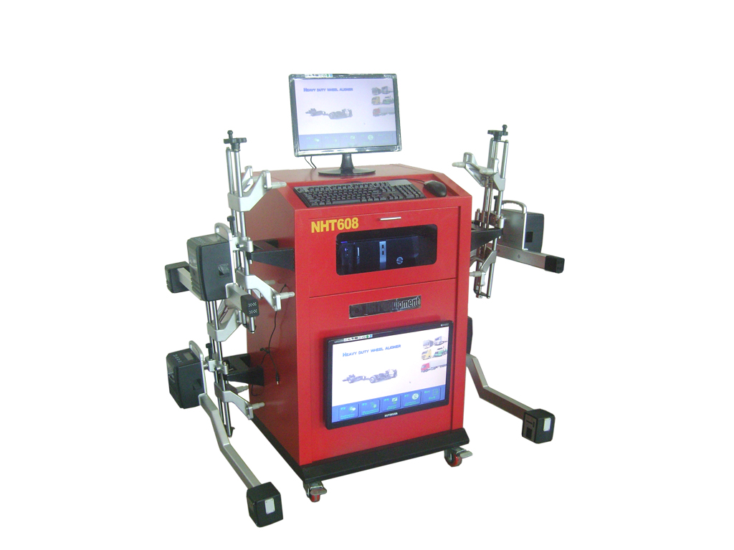

NO.9 | NHT701 3D wheel alignment.  3D/2D View Program, Durable target, 4 meter wheel base, Precise measurement, User friendly  FOB Dalian container price: USD7258  FOB Dalian sample price: USD7300  Durable Target:  - Passive target demanding no calibration  - Easy operation and maintenance due to no request for cable connection and battery charging  Convenient runout compensation procedure  Precise measurement:  - Stable light source  - Dynamic compensation measurement  - Real-time display of data makes the adjustment easier  Flexible measuring modes give easy access to users of traditional wheel aligners  User friendly:  - Advanced graph processing, mode identification and computer visual technology  Perfect 3D model on the base of Kinesiology, optical measurement and automotive technology. | 