● MEETING TITLE: Business cooperation between AUTOXUGA and GNS
● MEETING TIME：NOVEMBER 12, 2012
● MEETING PLACE：2nd Meeting room of GNS
● PARTICIPANTS:
GNS: Linda、George、Jayvee
AUTOXUGA: Alberto Castro Labandeira, Fernando Munoz Molina
● Recorder: George
● Subjects
1．Impeller
Some GNS water pumps are with a plastic impeller at present.
AUTOXUGA’s suggestion:
1). GNS may consider changing material of impeller from plastic to metal since plastic impeller has a worse life time than metal impeller. Autoxuga reflected more and more European OE manufacturers have given up plastic impeller and are replaced it with metal impeller.
2). AUTOXUGA accepted 4 water pumps with plastic impeller under first order. For future orders, AUTOXUGA hopes GNS can provide metal impeller for all water pumps. If GNS can’t do it, GNS will timely inform AUTOXUGA when receiving orders from AUTOXUGA.

- Bearing
For bearing, currently there are three situations of bearing option of GNS water pumps:
1). Some water pump which only has ball-ball bearing option.
2). Some water pump which only has ball-roller bearing option.
3). Some water pump which has ball-ball bearing and ball-roller bearing two options.
AUTOXUGA’s suggestion:
1). Water pump with ball-roller bearing has a longer life time than water pump with ball-ball bearing because AUTOXUGA think Water pump with ball-roller bearing can bear more extra force than Water pump with ball-ball bearing under same working condition.
2). AUTOXUGA accepted those water pumps with ball-ball bearing under first order.
3). For future orders, GNS can do as below: For water pump which has ball-ball bearing and ball-roller bearing two options, GNS will preferentially provide water pump with ball-roller bearing to AUTOXUGA; For water pump which only has ball-ball bearing option, GNS will timely inform AUTOXUGA when receiving orders from AUTOXUGA.

- Pulley
1). AUTOXUGA reflects belt on right in below picture is more popular and scientific than the one on left, due to this reason design of the pulley on right in below picture is preferred by customers.
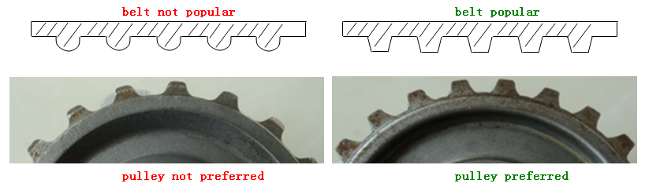
2). AUTOXUGA reflected pulley with hole is preferred by customers because in same high temperature environment pulley with hole shows more excellent performance than pulley without hole.
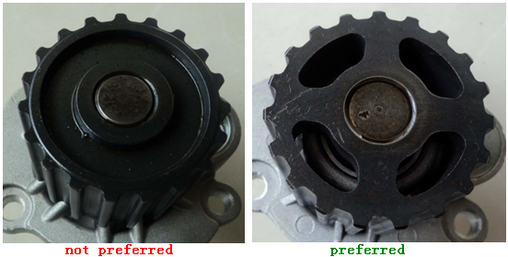
We will forward above two good advice regarding pulley to our technical department to see if there is any possible to improve GNS products.

4. Since design of same water pump of OE manufacturer is changing from time to time, AUTOXUGA hopes GNS pay close attention to this point and improve GNS water pump accordingly. GNS also hopes AUTOXUGA can help GNS to get such information from market if possible.

5. Package for Autoxuga goods
1). GNS individual box(see below picture), neutral multibox, pallet(120cm*80cm). (confirmed)
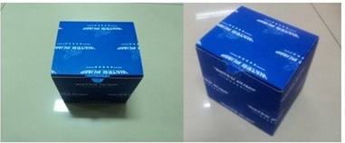

2). Mark on pump body (engraved by laser).
GNS + Production date (format: YYMM)" (confirmed)
For example, the production date May 2013 will be printed as “1305”

3). Individual box Label (posted on individual box):
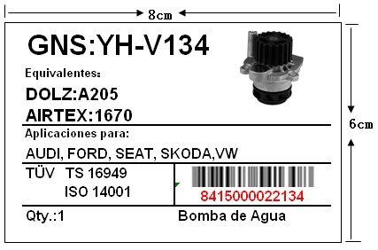
①individual box label size 8cm*6cm. (confirmed)
②water pump picture (taken by GNS) printed on individual box label. (confirmed)
③Teeth Qty. of gear and Diameter of bearing will not be shown on the label. (confirmed)
④GNS Part No. must include "YH-", it should be "YH-V134" instead of V134. (confirmed).
⑤Label will be posted on left side of individual box. (confirmed)
⑤ As we discussed in the meeting, we will create barcode according to “Reference list for barcode creating“ as below:
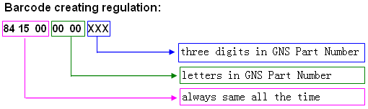

Reference list for barcode creating:
Letter | A | B | C | D | E | F | G | H | I | J | K | L | M
Code | 1 | 2 | 3 | 4 | 5 | 6 | 7 | 8 | 9 | 10 | 11 | 12 | 13
Letter | N | O | P | Q | R | S | T | U | V | W | X | Y | Z
Code | 14 | 15 | 16 | 17 | 18 | 19 | 20 | 21 | 22 | 23 | 24 | 25 | 26

However, I found a new problem after the meeting.
Some of our water pumps are like YH-V136-2, YH-RE110-2 etc. How should we create barcode for these items?
Some of our water pumps are like YH-RE102H, YH-P145H etc. How should we create barcode for these items?

5. Multibox Label (posted on front side of Multibox): (confirmed by Agustin by email)
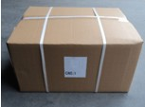
Front mark:
AUTOXUGA
CTN NO.:

Side mark (posted on left or right side of outer carton):
DOLZ NO.:
QTY:
G.W.:
MEAS.:

6. Shipping mark (posted on pallet) (confirmed by Agustin by email)
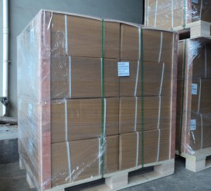
Our suggestion:
AUTOXUGA
PLT NO.:

7. Payment term: 30% deposit, 70% upon receipt of B/L copy. (confirmed by Agustin)
8. Price term: FOB Ningbo/Shanghai (confirmed by Agustin)
9. Lead time: 60 days after you confirm our proforma invoice. (confirmed by Agustin)

Issues need to be done ：
- Barcode:
How should we create barcode when we confront water pumps like YH-V136-2, YH-RE110-2, YH-RE102H, YH-P145H etc.?

