
Meeting Report
● MEETING TITLE: Business cooperation between AUTOXUGA and MAOJIA
● MEETING TIME：MARCH 30, 2013
● MEETING PLACE：2nd Meeting room of MAOJIA
● PARTICIPANTS:
MAOJIA: Lesley Zhang、John Zhao
AUTOXUGA: Alberto Castro, Agustín Jamardo
● Recorder: Lesley

- The delivery time
The delivery time is June 30 for both kit order and PK belt order.

- Timing mark
According to the samples you give us, we print timing mark on the timing belt for you. It’s for belt assemble use. We pay the cost for you this time. As there’re only two belts need timing mark.
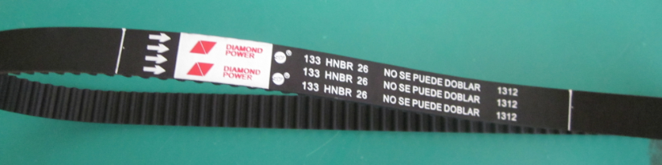

- Belt width
We will try our best to make the belt width to close the upper tolerance. But it’s controlled by computer and it’s something to do with cutting angle. So it’s impossible to make all the belts are with the upper tolerance. But we can sure we will make your belts width at most the lower tolerance during 0.1-0.2mm. It’s already very very small tolerance

- Bearing shape is ball or column?
We check the Dayco sample you sent us, all the bearing use ball shape. We also check with our engineer the function for ball shape and column shape. The column shape bearing has more contact area than ball’s. But the running speed of column shape is lower than ball. When the engine running fast, if use column shape bearing, as its contact area is big, the heating is as well high. So it will damage the tensioner easily. We use ball-shaped bearing.
Acturally, if the running speed is low and loading is huge, the column-shaped bearing is used ussually. If running speed is fast and load is relatively small, the ball-shaped bearing is used uasually.

- KTB197 and KTB534 tensioner
We supply the tensioners for KTB197 and KTB534 are the same. But the Dayco sample is a little different for KTB197 and KTB534. We check with you the below information. You confirm it.
5.1.1a: the D2=22mm,while your sample both 2a and 3a: D2=34mm.

- Box and sleeve

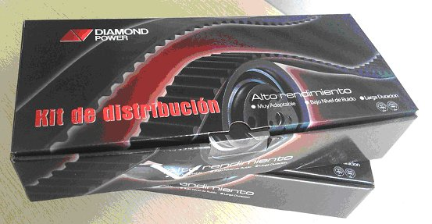

- Label
I attached a copy of 17 sets kit label. Pls check it.

